**RABIA BATOOL**

**2022-BSE-067**

**PF LAB MANUAL**

**Submitted to: Sir Shoaib**

**Lab #1**

**Program # I**

// rabia lab 2.cpp : Defines the entry point for the console application.

//

#include "stdafx.h"

#include<iostream>;

using namespace std;

//int main()

int _tmain(int argc, _TCHAR* argv[])

{

cout<<"hello"<<endl<<"world";

system("pause");

return 0;

}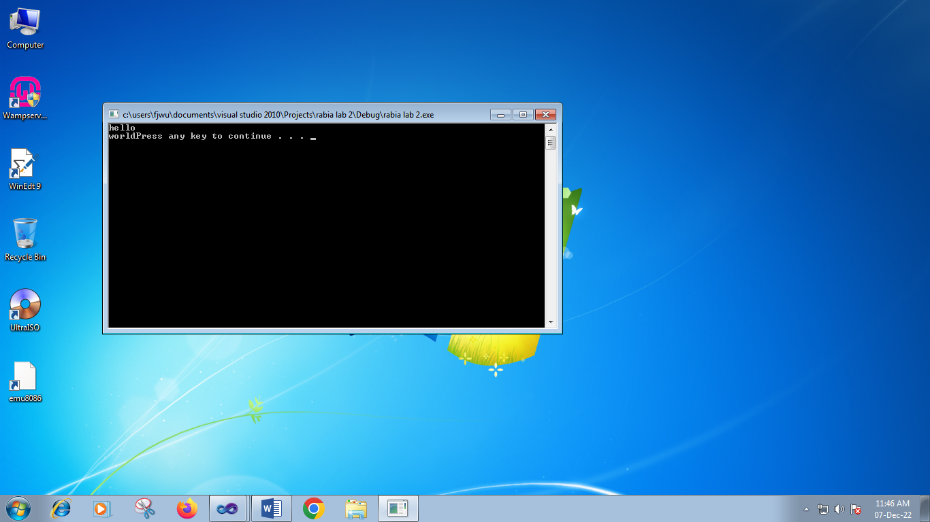

**Lab #2**

**PROGRAM # II**

// rabia lab 2 prog 2.cpp : Defines the entry point for the console application.

//

#include "stdafx.h"

#include<iostream>;

using namespace std;

int _tmain(int argc, _TCHAR* argv[])

{

int a;

int b;

a=10;

b=20;

cout<<"a="<<a<<endl;

cout<<"b="<<b<<endl;

system("pause");

return 0;

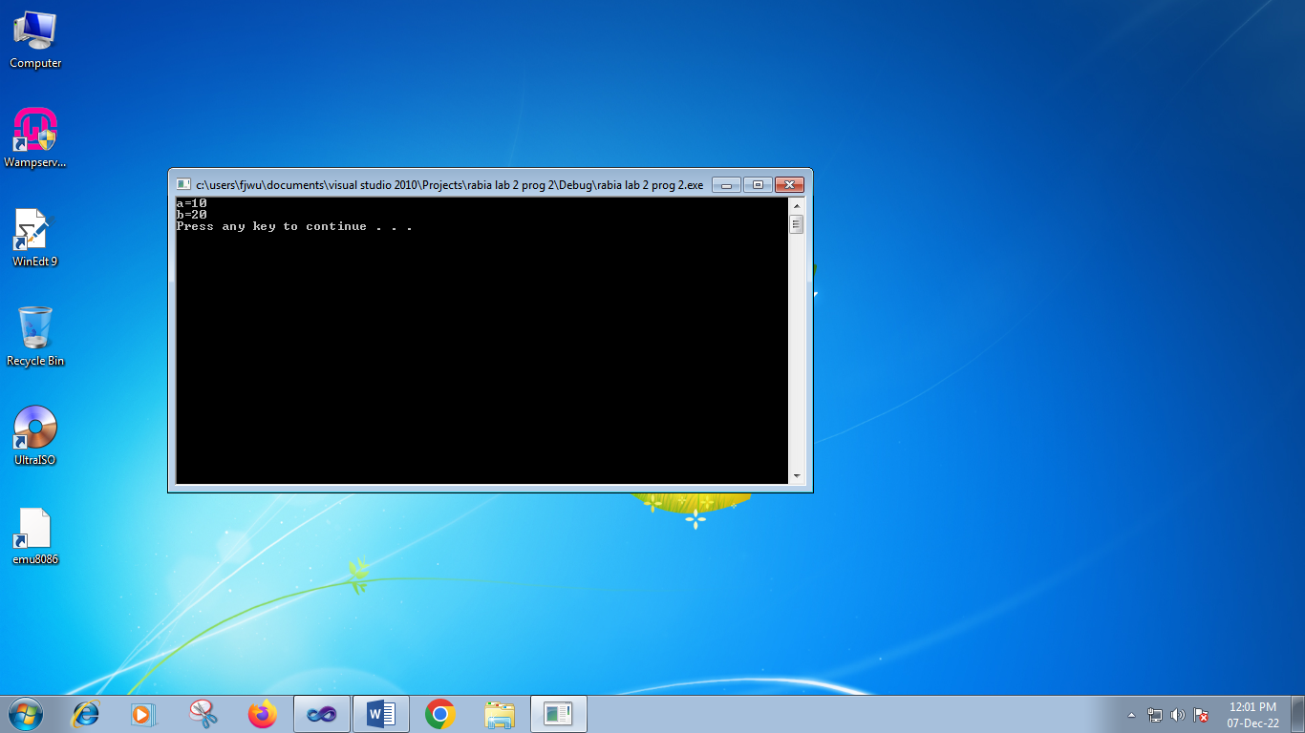

**PROGRAM # III**

// rabia.cpp : Defines the entry point for the console application.

//

#include "stdafx.h"

#include<iostream>;

using namespace std;

int _tmain(int argc, _TCHAR* argv[])

{

cout<<"hello world"<<endl;

int a=10;

int b=20;

int c;

c=a+b;

cout<<a<<"+"<<b<<"="<<c<<endl;

system("pause");

return 0;

}

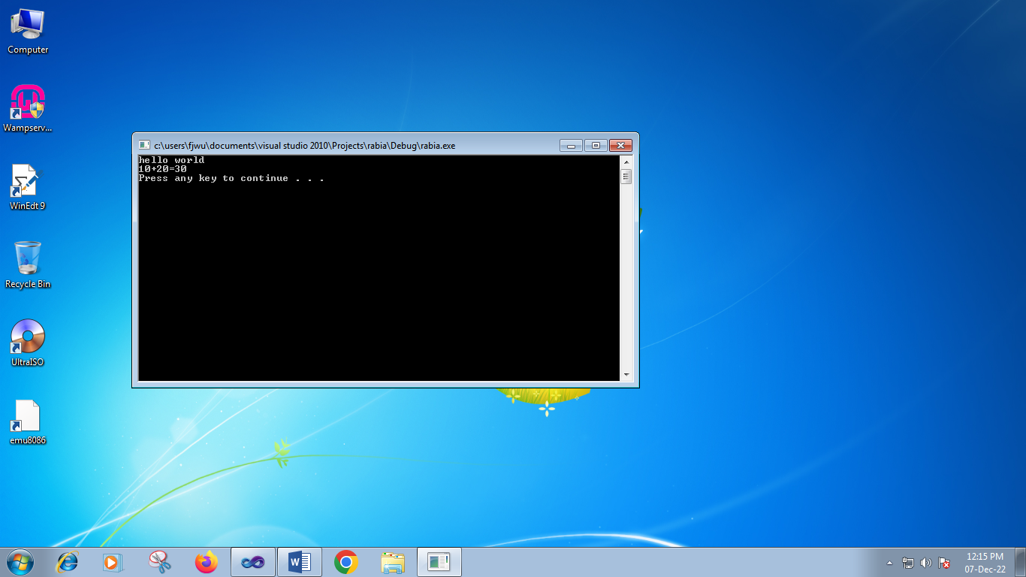

**TASK :2**

// rabia 3.cpp : Defines the entry point for the console application.

//

#include "stdafx.h"

#include<iostream>;

using namespace std;

int _tmain(int argc, _TCHAR* argv[])

{

int age=18;

cout<<"my name is rabia batool"<<endl<<"my age is"<<age<<endl;

system("pause");

return 0;

}

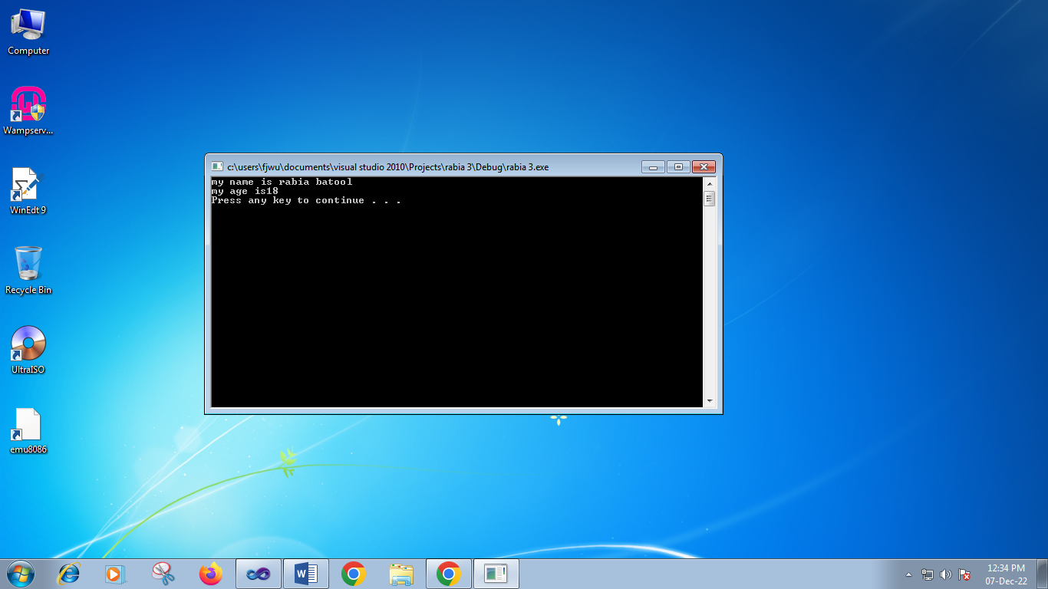

**TASK :3**

// rabia 3.cpp : Defines the entry point for the console application.

//

#include "stdafx.h"

#include<iostream>;

using namespace std;

int _tmain(int argc, _TCHAR* argv[])

{

int a=20;

int b=40;

int x;

int y;

int z;

x=a+b;

y=a-b;

z=a*b;

cout<<"sum of a and b="<<x<<endl;

cout<<"subtruction of a and b="<<y<<endl;

cout<<"multiplication of a and b="<<z<<endl;

system("pause");

return 0;

}

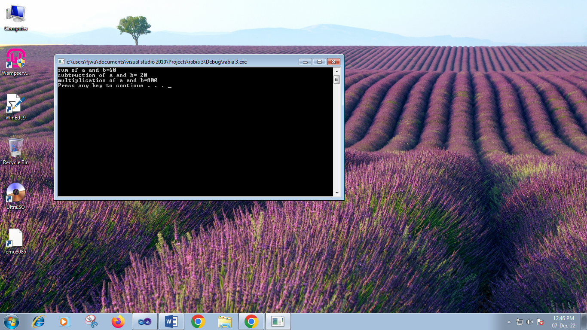

**TASK :4**

// rabia4.cpp : Defines the entry point for the console application.

//

#include "stdafx.h"

#include<iostream>;

using namespace std;

int _tmain(int argc, _TCHAR* argv[])

{

int A=12;

int B=13;

int x;

float c=10.0;

float d=2.0;

int y;

x=A%B;

y=c/d;

cout<<"Division of c and d ="<<y<<endl;

cout<<"mode of A and B ="<<x<<endl;

system("pause");

return 0;

}

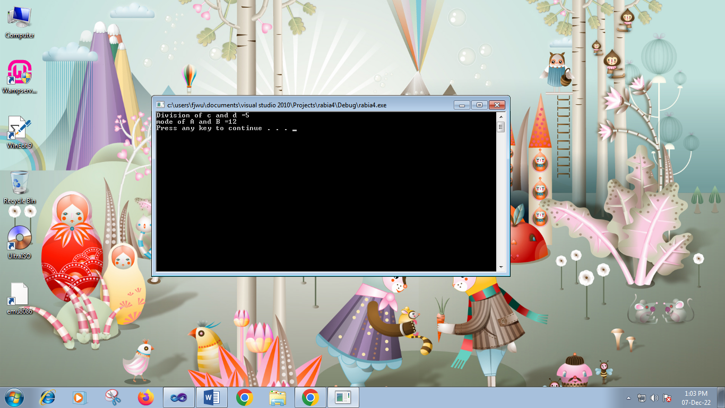

**TASK :5**

// rabia4.cpp : Defines the entry point for the console application.

//

#include "stdafx.h"

#include<iostream>;

using namespace std;

int _tmain(int argc, _TCHAR* argv[])

{

int a=12;

int b=4;

int c=0;

cout<<"Before swaping ="<<endl;

cout<<"a="<<a<<endl;

cout<<"b="<<b<<endl;

c=a;

b=c;

a=b;

cout<<"after swaping ="<<endl;

cout<<"a"<<a<<endl;

cout<<"b"<<b<endl;

system("pause");

return 0;

}

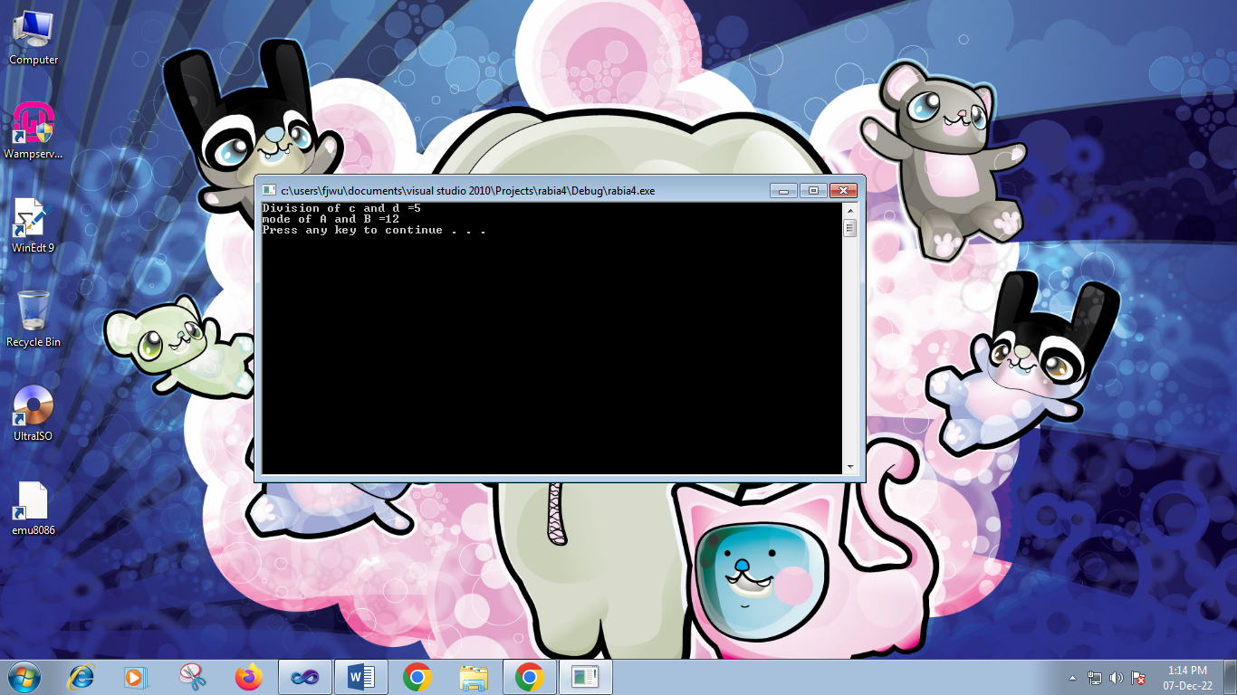

**Lab # 3**

**Task 1**

// lab.rabia 3.cpp : Defines the entry point for the console application.

//

#include "stdafx.h"

#include<iostream>

using namespace std;

int _tmain(int argc, _TCHAR* argv[])

{int a=5;

cout<<a<<endl;

cout<<a*4<<endl;

cout<<a*6<<endl;

cout<<a*5<<endl;

system("pause");

return 0;

}

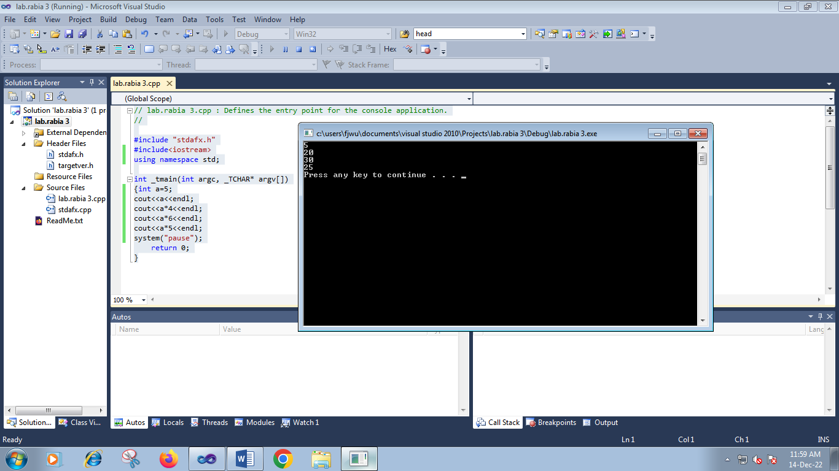

**Task #2**

// lab rabia 3.cpp : Defines the entry point for the console application.

//

#include "stdafx.h"

#include<iostream>

using namespace std;

int _tmain(int argc, _TCHAR* argv[])

{int a,b;

int c;

cout<<"please enter the value of a"<<endl;

cin>>a;

cout<<"please enter the value of b"<<endl;

cin>>b;

c= a&&b;

cout<<"and of"<<a<<"and"<<b<<"="<<c<<endl;

return 0;

}

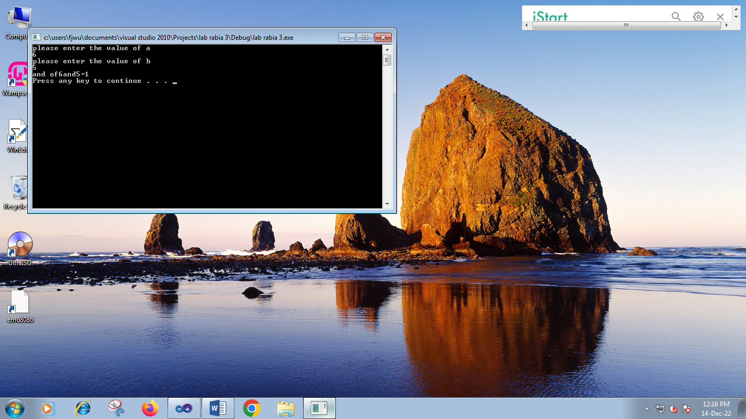

**Task3**

// 3 lab rabia.cpp : Defines the entry point for the console application.

//

#include "stdafx.h"

#include<iostream>

using namespace std;

int _tmain(int argc, _TCHAR* argv[])

{int a,b;

int a=0; b=1;

cout<<"A B X"<<endl;

cout<<a<<" "<<a<<" "<<(a||a)<<endl;

cout<<a<<" "<<b<<" "<<(a||b)<<endl;

cout<<b<<" "<<b<<" "<<(b||b)<<endl;

cout<<b<<" "<<a<<" "<<(b||b)<<endl;

system("pause");

return 0;

}

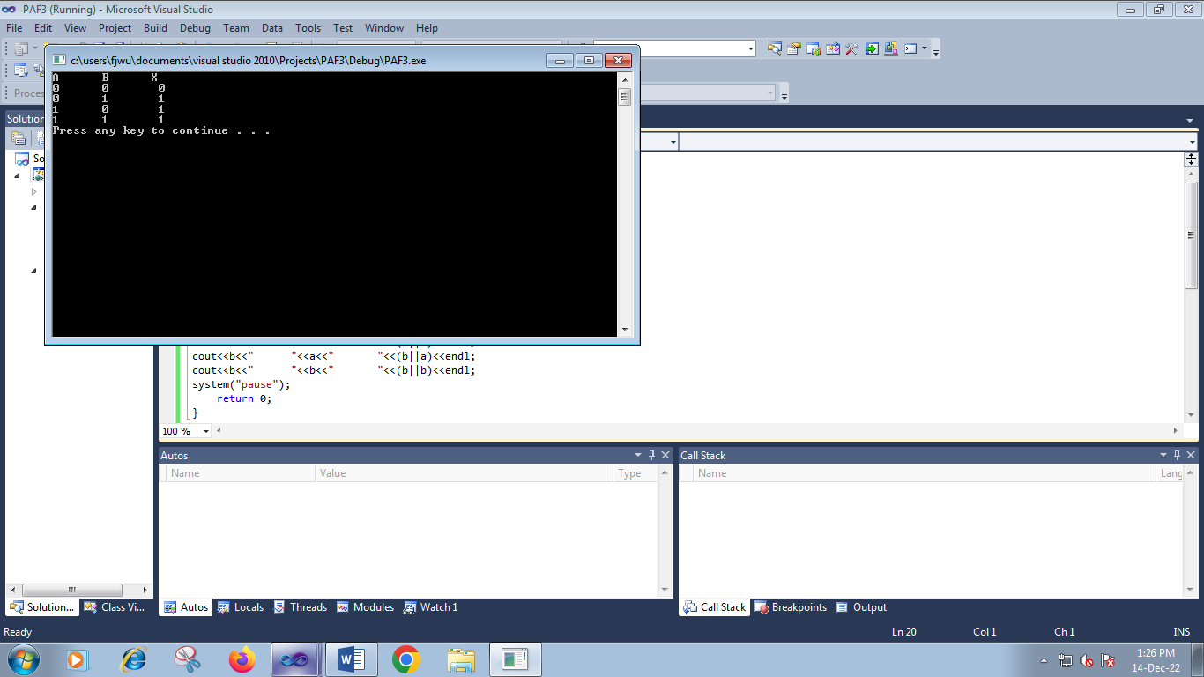

**Task# 4**

// num 1.cpp : Defines the entry point for the console application.

//

#include "stdafx.h"

#include<iostream>

using namespace std;

int _tmain(int argc, _TCHAR* argv[])

{float A,B,C,D,E;

float Tmarks;

float p;

cout<<"enter the marks of sub a ="<<endl;

cin>>A;

cout<<"enter the marks of sub b ="<<endl;

cin>>B;

cout<<"enter the marks of sub c="<<endl;

cin>>C;

cout<<"enter themarks of sub d="<<endl;

cin>>D;

cout<<"enter the marks of sub e="<<endl;

cin>>E;

Tmarks=A+B+C+D+E;

cout<<"total marks ="<<Tmarks<<endl;

p=(Tmarks*100)/500;

cout<<"p="<<p<<endl;

return 0;

}

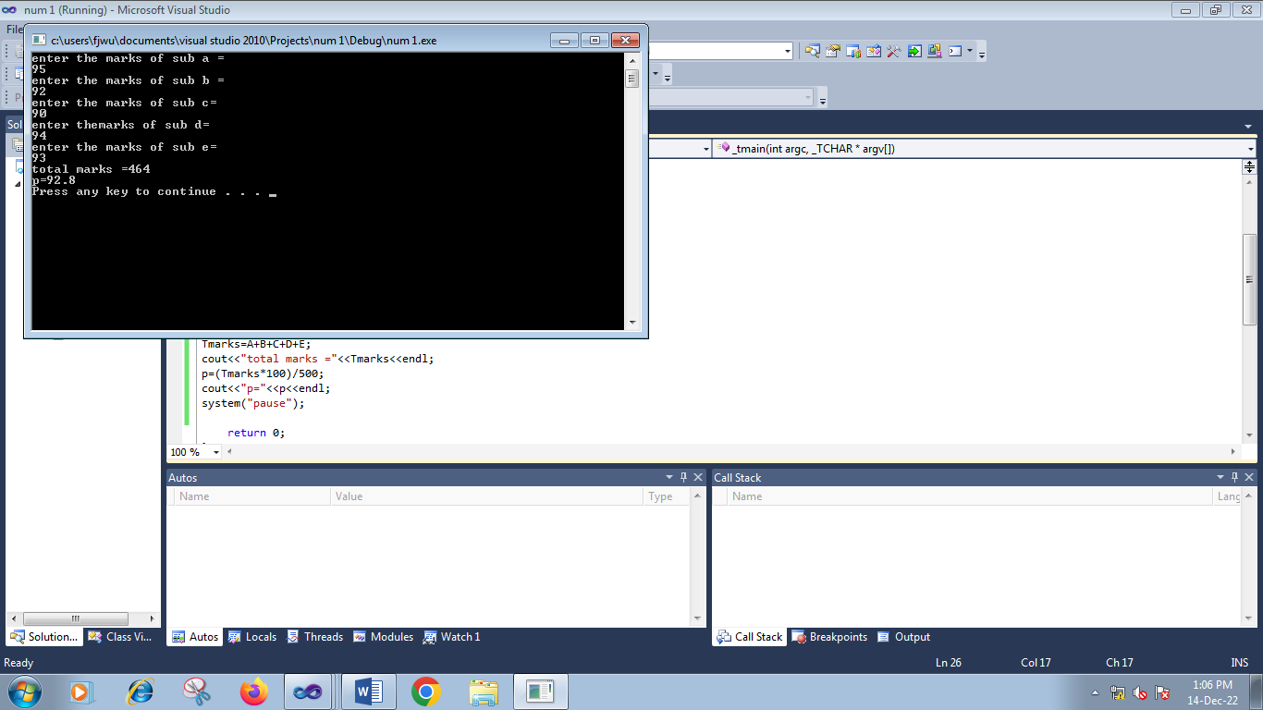

**Task#5**

// pf 4.cpp : Defines the entry point for the console application.

//

#include "stdafx.h"

#include<iostream>

using namespace std;

int _tmain(int argc, _TCHAR* argv[])

{float C,F;

cout<<"enter thetemperature in fahrenheit ="<<endl;

cin>>F;

C=(F-32)/1.8;

cout<<"temperature in centigrade ="<<C<<endl;

system("pause");

return 0;

}

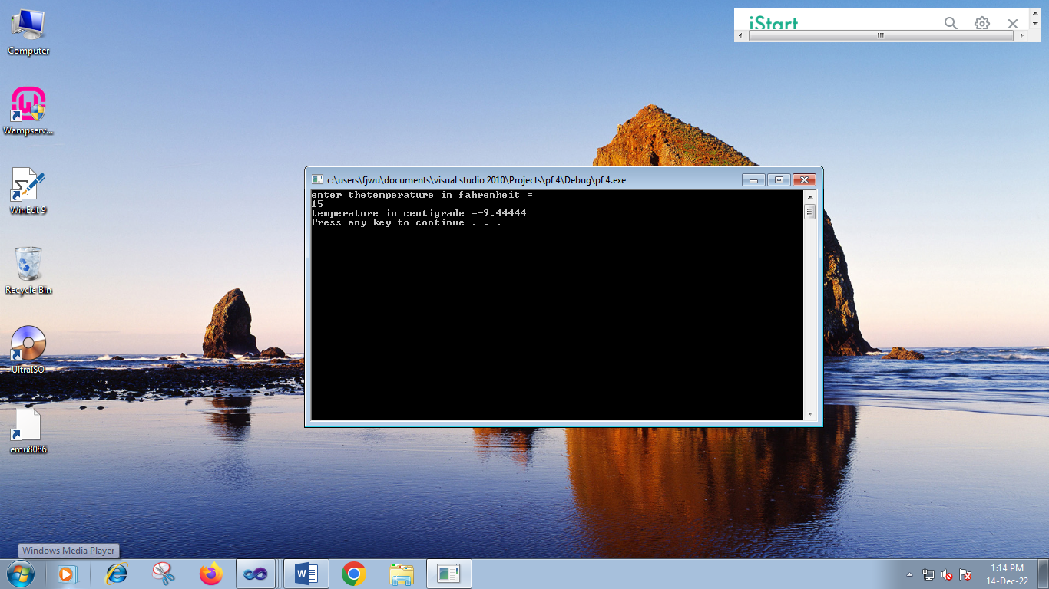

**Task# 6**

// PAFF.cpp : Defines the entry point for the console application.

//

#include "stdafx.h"

#include<iostream>

using namespace std;

int _tmain(int argc, _TCHAR* argv[])

{float F,a,b,c;

cout<<"enter the value of a"<<endl;

cin>>a;

cout<<"enter the value od b"<<endl;

cin>>b;

cout<<"enter the value of c"<<endl;

cin>>c;

F=(-b+b*b-4*a*c)/2*a;

cout<<"solution ="<<F<<endl;

system("pause");

return 0;

}

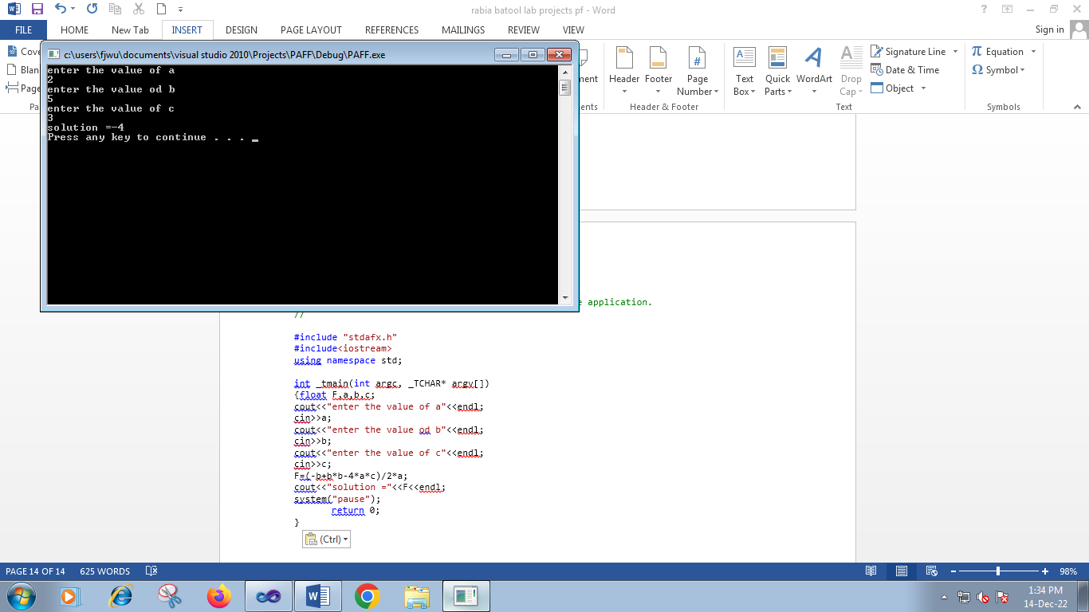

**Task #7**

// class 1.cpp : Defines the entry point for the console application.

//

#include "stdafx.h"

#include<iostream>

using namespace std;

int _tmain(int argc, _TCHAR* argv[])

{int X=7410;

int d1,d2,d3,d4,rem,sum;

cout<<"four digit number="<<X<<endl;

d1=(X)/1000;

rem=X%1000;

d2=(rem)/100;

rem=rem%100;

d3=(rem)/10;

rem=rem%10;

d4=(rem)/1;

rem=rem%1;

sum=d1+d2+d3+d4;

cout<<"sum="<<sum<<endl;

system("pause");

return 0;

}

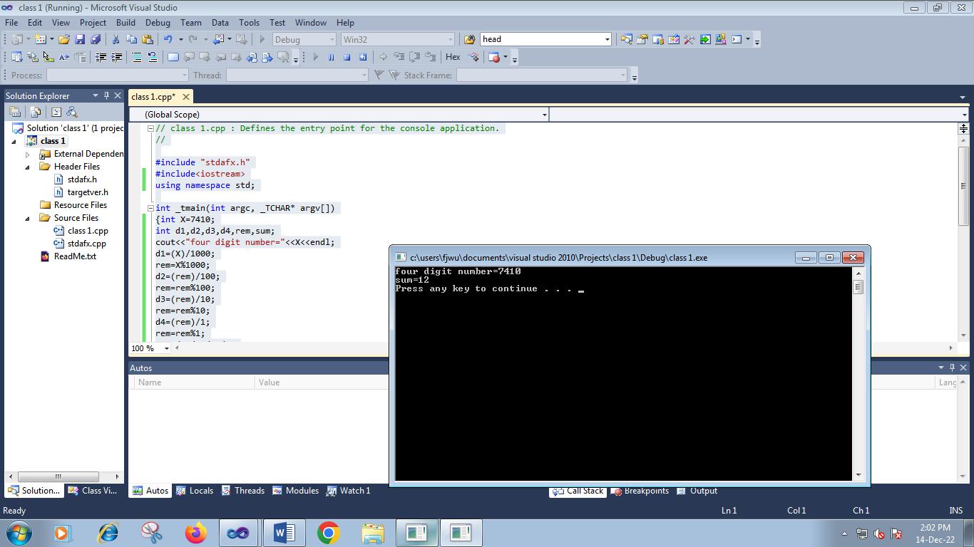

**LAB#4**

**Task 1**

/ rabia lab 4.cpp : Defines the entry point for the console application.

//

#include "stdafx.h"

#include<iostream>

using namespace std;

int _tmain(int argc, _TCHAR* argv[])

{int a,b;

cout<<"use of if else ststement"<<endl;

cout<<"enter a number"<<endl;

cin>>a;

cout<<"enter another number"<<endl;

cin>>b;

if(a>b)

cout<<"first number is greater"<<endl;

else

cout<<"second number is largest"<<endl;

system("pause");

return 0;

}

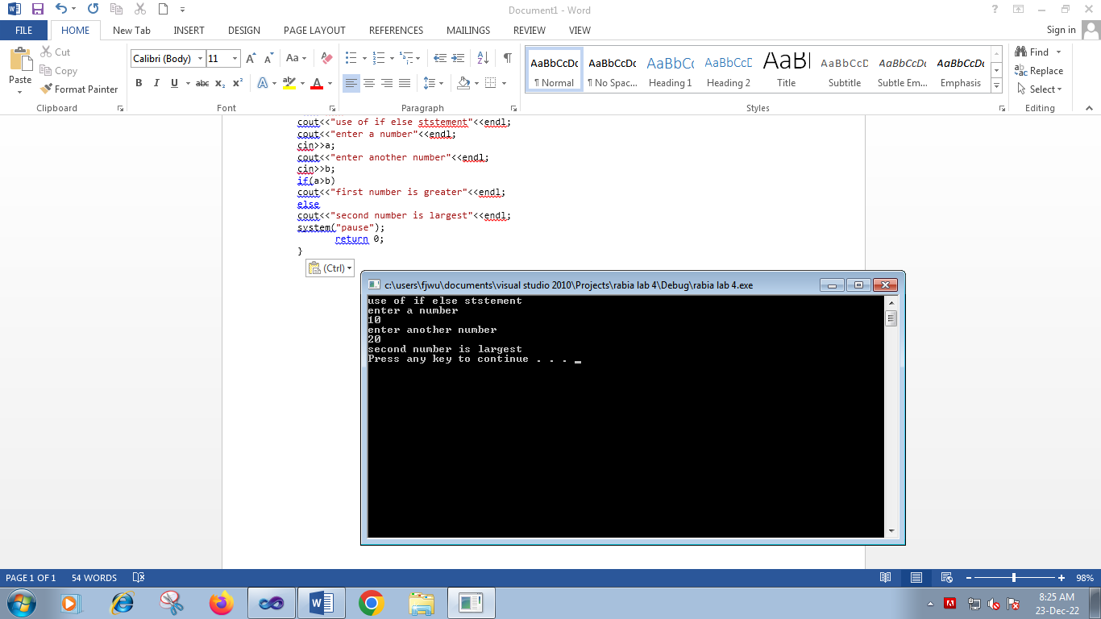

/ rabia lab 4.cpp : Defines the entry point for the console application.

//

#include "stdafx.h"

#include<iostream>

using namespace std;

int _tmain(int argc, _TCHAR* argv[])

{int a=100,b=2000,c=300;

cout<<"use of nested if else statement"<<endl;

if(a>b)

{if(a>c)

cout<<a<<"is largest"<<endl;

else if (c>b)

cout<<c<<"is largest"<<endl;

}

else

{if(b>c)

cout<<b<<"is largest"<<endl;

else

cout<<c<<"is largest"<<endl;

}

system("pause");

return 0;

}

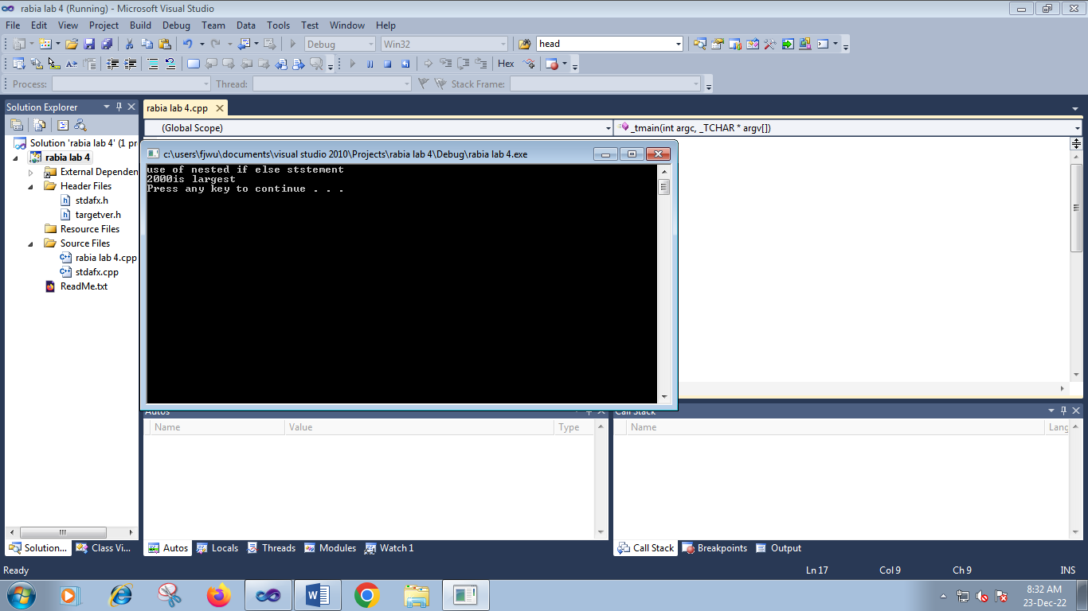

**Task 2**

/ rabia lab 4.cpp : Defines the entry point for the console application.

//

#include "stdafx.h"

#include<iostream>

using namespace std;

int _tmain(int argc, _TCHAR* argv[])

{int n;

cout<<"enter a number"<<endl;

cin>>n;

if(n%2==0)

cout<<"number is even"<<endl;

else

cout<<"number is odd"<<endl;

system("pause");

return 0;

}

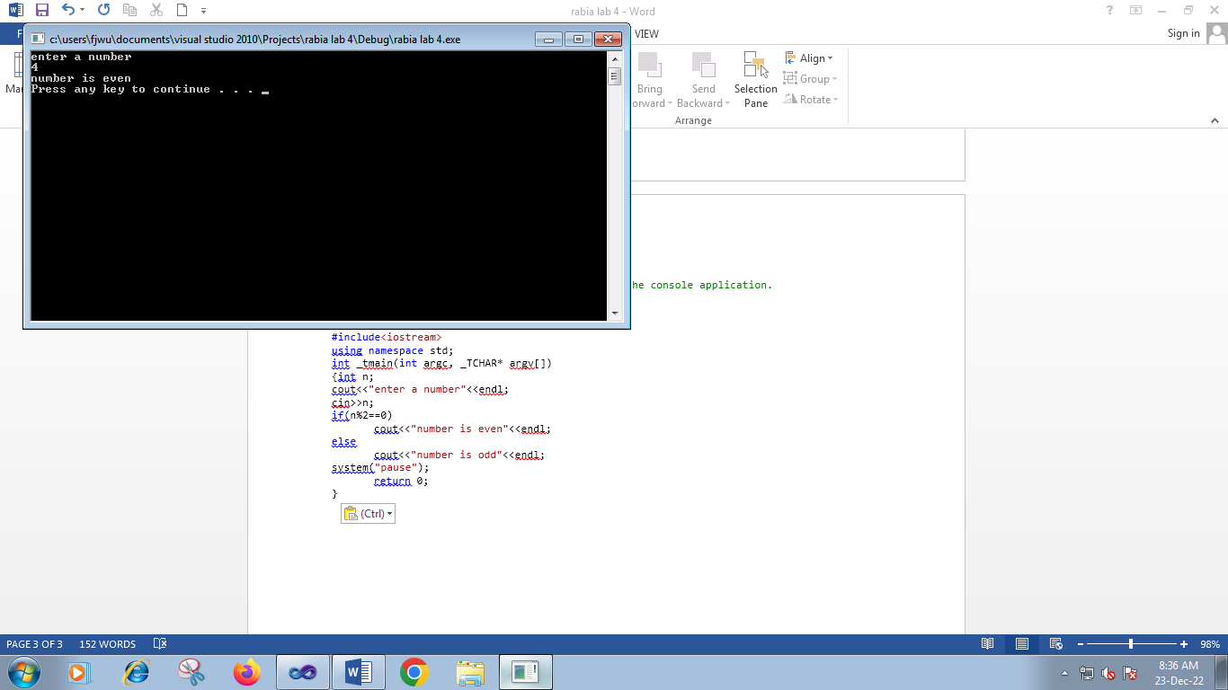

**Task 3**

/ rabia lab 4.cpp : Defines the entry point for the console application.

//

#include "stdafx.h"

#include<iostream>

using namespace std;

int _tmain(int argc, _TCHAR* argv[])

{int a,b,c;

cout<<"enter number"<<endl;

cin>>a;

cout<<"enter a number"<<endl;

cin>>b;

cout<<"enter last number"<<endl;

cin>>c;

if(a<b)

{if(a<c)

cout<<a<<"is smallest"<<endl;

else

if(c<b)

cout<<c<<"ia smallest"<<endl;

}

else

{if(b<a)

cout<<b<<"is smallest"<<endl;

else

cout<<c<<"is smallest"<<endl;

}

system("pause");

return 0;

}

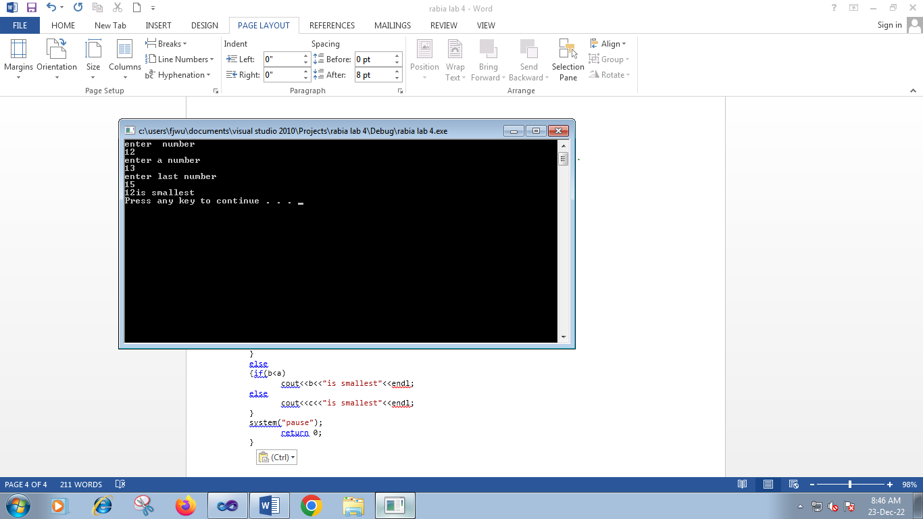

**Task 4**

/ rabia lab 4.cpp : Defines the entry point for the console application.

//

#include "stdafx.h"

#include<iostream>

using namespace std;

int _tmain(int argc, _TCHAR* argv[])

{int a,b,c,d;

cout<<"enter number"<<endl;

cin>>a;

cout<<"enter a number"<<endl;

cin>>b;

cout<<"enter number"<<endl;

cin>>c;

cout<<"enter a num"<<endl;

cin>>d;

if(a>b && a>c && a>d)

cout<<a<<"is largest"<<endl;

else

if(b>a && b>c && b>>d)

cout<<b<<"is largest"<<endl;

else

if(c>a && c>b && c>d)

cout<<c<<"is largest"<<endl;

else

cout<<d<<"is largest"<<endl;

system("pause");

return 0;

}

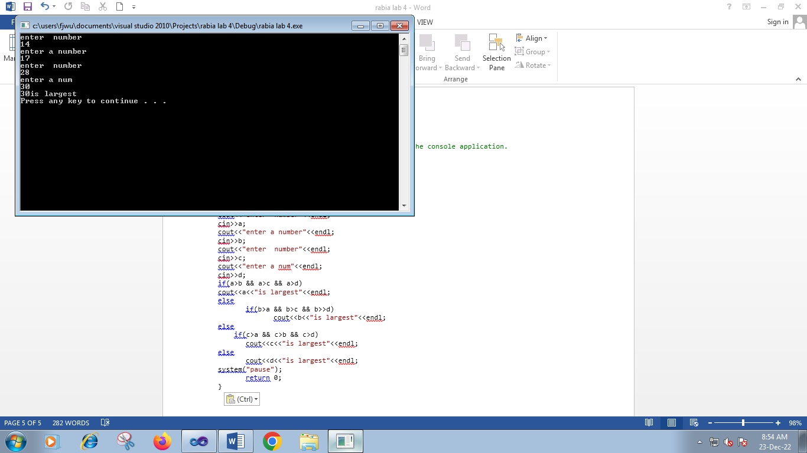

**Task 5**

/ rabia lab 4.cpp : Defines the entry point for the console application.

//

#include "stdafx.h"

#include<iostream>

using namespace std;

int _tmain(int argc, _TCHAR* argv[])

{int a,b;

char op;

cout<<"enter number"<<endl;

cin>>a;

cout<<"enter a number"<<endl;

cin>>b;

cout<<"enter an operator"<<endl;

cin>>op;

if(op='+')

{cout<<"addition="<<(a+b)<<endl;}

else

if(op='-')

{cout<<"subtruction"<<(a-b)<<endl;}

else

if(op='*')

{cout<<"multiplication="<<(a*b)<<endl;}

else if (op='/')

{cout<<"division="<<(a/b)<<endl;}

system("pause");

return 0;

}

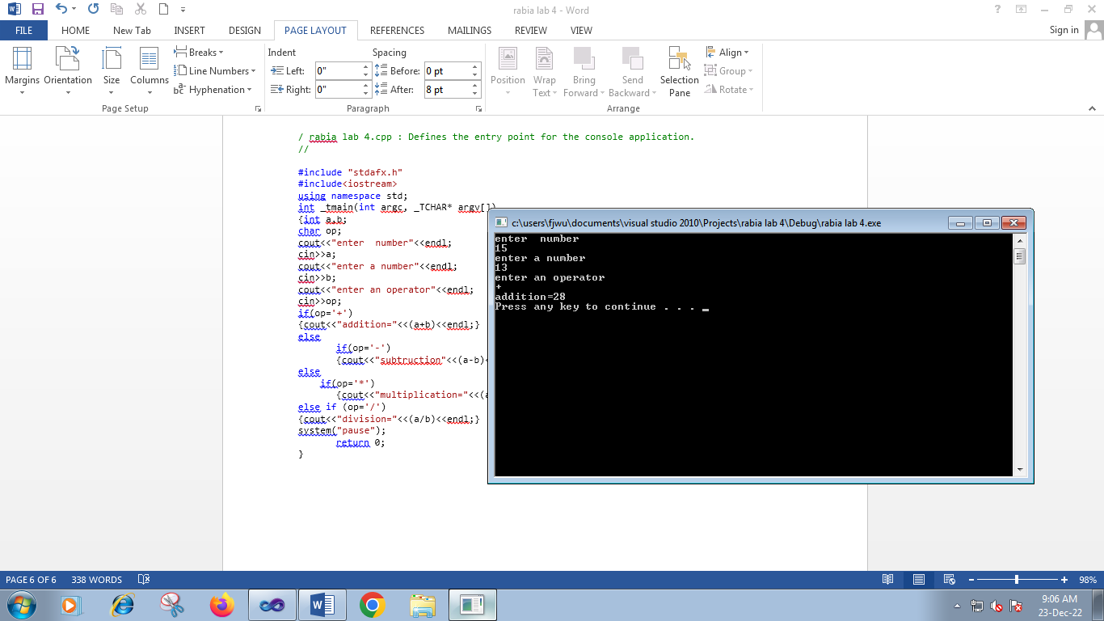

**Task 6**

/ rabia lab 4.cpp : Defines the entry point for the console application.

//

#include "stdafx.h"

#include<iostream>

using namespace std;

int _tmain(int argc, _TCHAR* argv[])

{int a,b,c,angle;

cout<<"enter first angle"<<endl;

cin>>a;

cout<<"enter second angle"<<endl;

cin>>b;

cout<<"enter third angle"<<endl;

cin>>c;

angle=a+b+c;

if(angle==180)

cout<<"it is a triangle"<<endl;

else

cout<<"it s not a triangle"<<endl;

system("pause");

return 0;

}

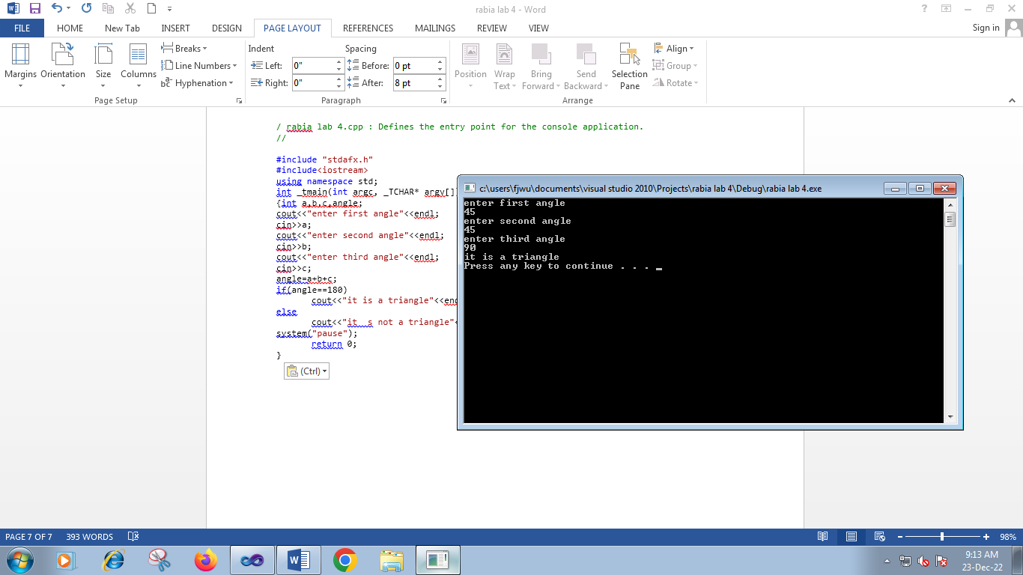

**Task 7**

/ rabia lab 4.cpp : Defines the entry point for the console application.

//

#include "stdafx.h"

#include<iostream>

using namespace std;

int _tmain(int argc, _TCHAR* argv[])

{int days ;

cout<<"enter the return day"<<endl;

cin>>days;

if(days<=7)

cout<<"your fine is10pkr"<<endl;

else if(days>=8 || days<=14)

cout<<"your fine is 20 pkr"<<endl;

else if(days>=15 ||days<=31)

cout<<"your fine is 50 pkr"<<endl;

else

cout<<"your membership is cancelled"<<endl;

system("pause");

return 0;

}

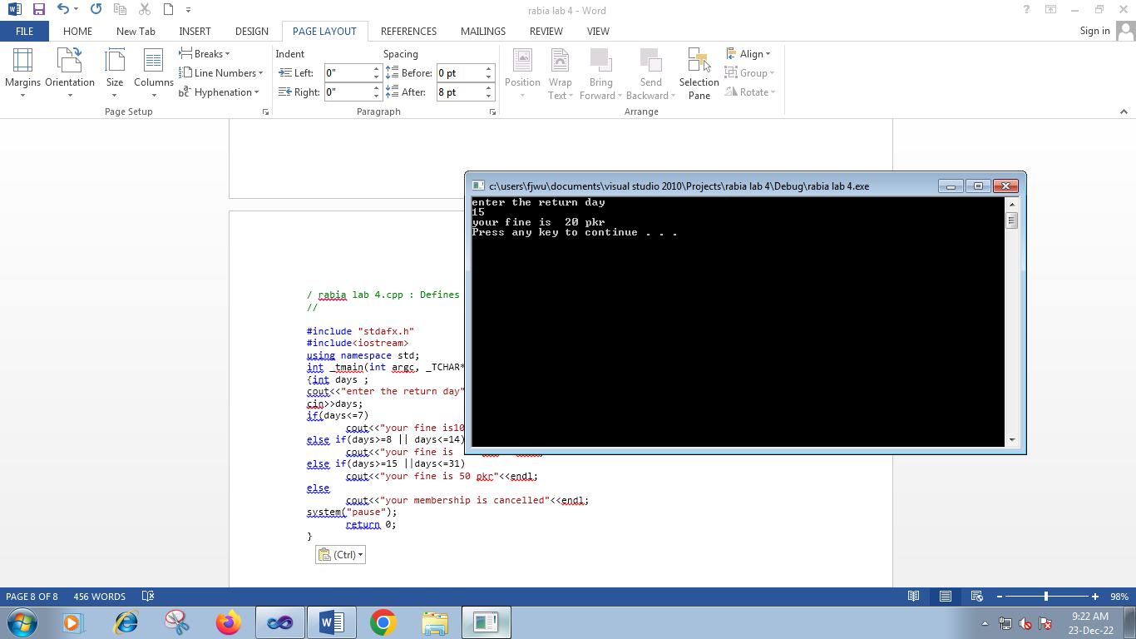

***Lab #5***

**Task #1**

// amjnbn.cpp : Defines the entry point for the console application.

//

#include "stdafx.h"

#include<iostream>

using namespace std;

int _tmain(int argc, _TCHAR* argv[])

{int a;

cout<<"please enter any value from 1-3"<<endl;

cin>>a;

switch(a)

{case 1:

cout<<"you have enter 1"<<endl;

break;

case 2:

cout<<"you have entered 2"<<endl;

break;

case 3:

cout<<"you have enter 3"<<endl;

break;

default:

cout<<"you have entered other number" <<endl;

}

system ("pause");

return 0;

}

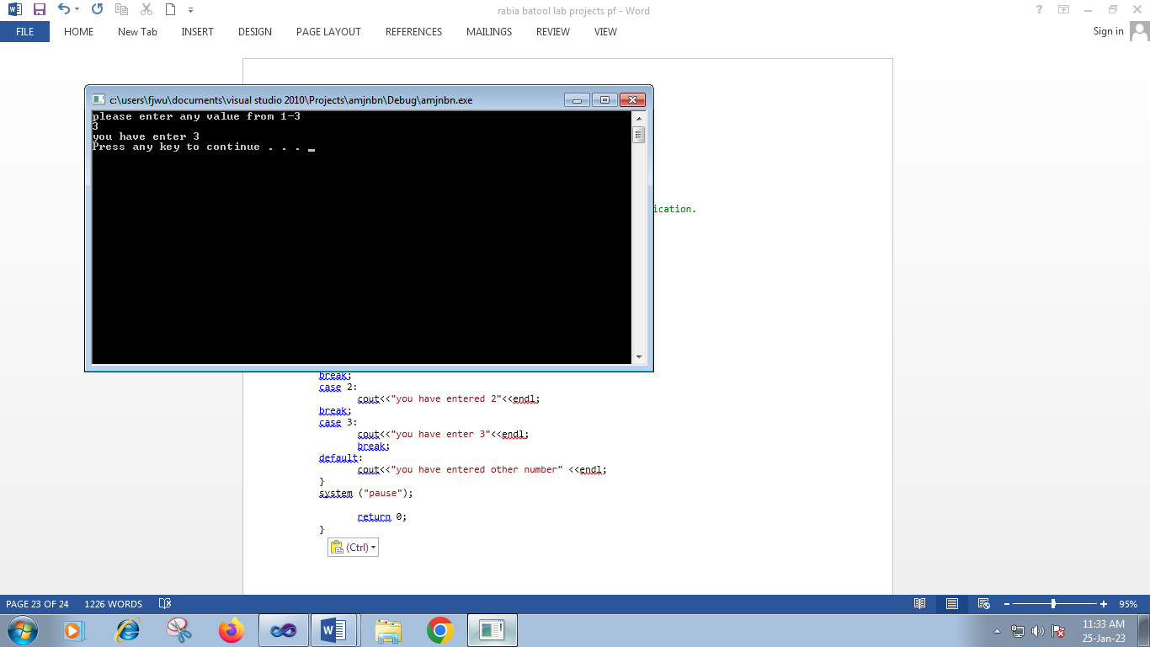

**Task #2**

// amjnbn.cpp : Defines the entry point for the console application.

//

#include "stdafx.h"

#include<iostream>

using namespace std;

int _tmain(int argc, _TCHAR* argv[])

{char op,a,b;

cout<<"please enter an operator"<<endl;

cin>>op;

cout<<"enter two num"<<endl;

cin>>a;

cin>>b;

switch(a)

{case ('+'):

cout<<"add a and b"<<(a+b)<<endl;

break;

case ('-'):

cout<<"subtruct a and b"<<(a-b)<<endl;

break;

case ('*'):

cout<<"multiply a and b"<<(a*b)<<endl;

break;

case('/'):

cout<<"divide a and b"<<(a/b)<<endl;

break;

default:

cout<<"you have entered wrong operator" <<endl;

}

system ("pause");

return 0;

}

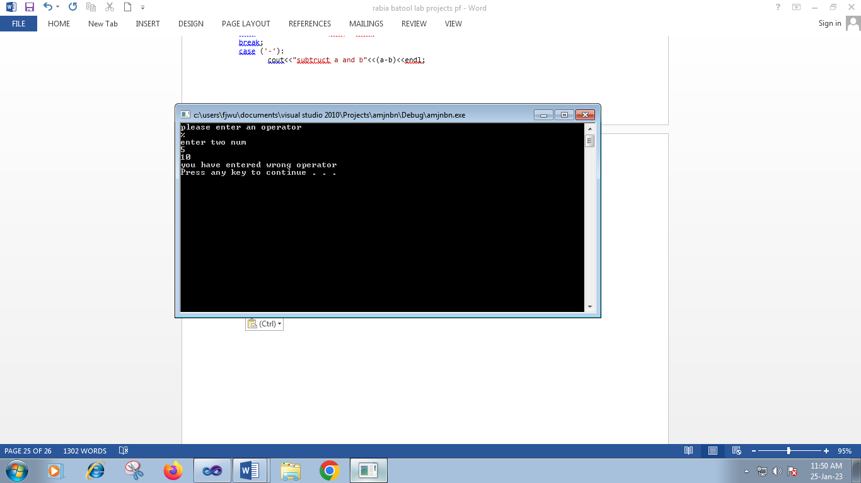

**Task # 3**

// amjnbn.cpp : Defines the entry point for the console application.

//

#include "stdafx.h"

#include<iostream>

using namespace std;

int _tmain(int argc, _TCHAR* argv[])

{char ch;

cout<<"please enter an character"<<endl;

cin>>ch;

switch(ch)

{case ('a'):

cout<<"you enter vowel a"<<endl;

break;

case ('e'):

cout<<"you have enter vowel e"<<endl;

break;

case ('i'):

cout<<"you have enter vowel i"<<endl;

break;

case('o'):

cout<<"you have enter vowel o"<<endl;

break;

case('u'):

cout<<"you have enter vowel u"<<endl;

break;

default:

cout<<"you have entered consonant" <<endl;

}

system ("pause");

return 0;

}

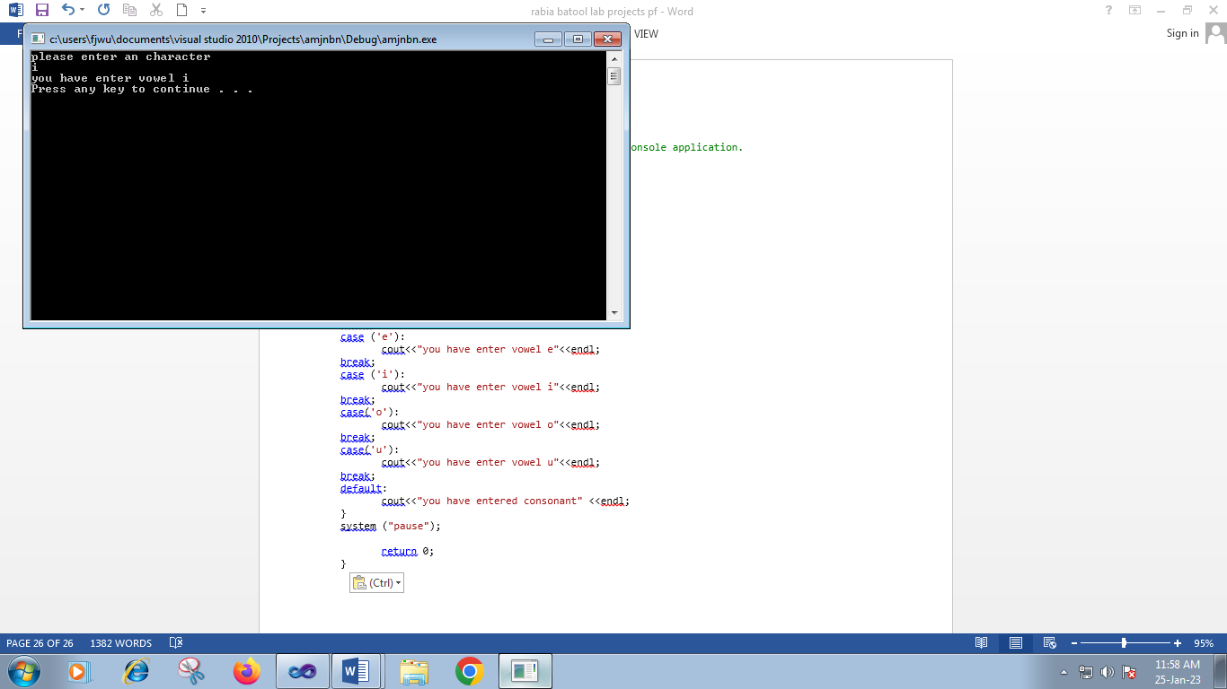

**Task #4( I)**

// amjnbn.cpp : Defines the entry point for the console application.

//

#include "stdafx.h"

#include<iostream>

using namespace std;

int _tmain(int argc, _TCHAR* argv[])

{int i=0;

while(i<10)

{cout<<"i"<<endl;

i++;

}

system ("pause");

return 0;

}

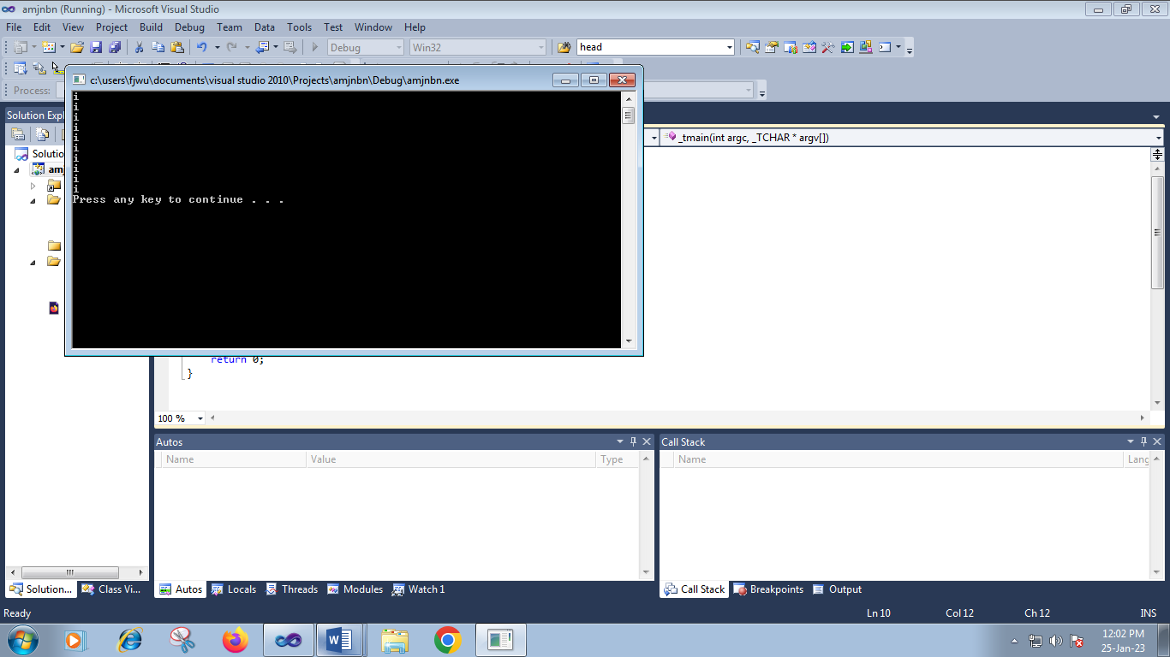

**Task # 4 (II)**

// enu.cpp : Defines the entry point for the console application.

//

#include "stdafx.h"

#include<iostream>

using namespace std;

int _tmain(int argc, _TCHAR* argv[])

{

cout<<"use of do while"<<endl;

int i=20;

do

{cout<<i<<endl;

i--;

}while(i>0);

system ("pause");

return 0;

}

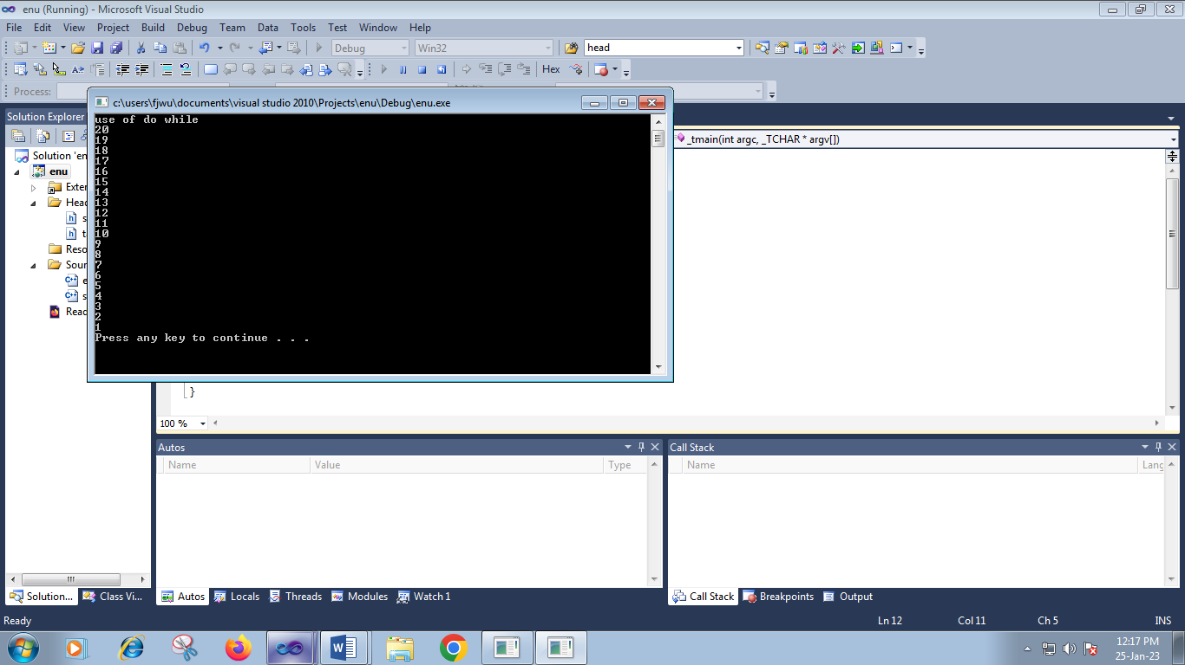

**Task #5**

// amjnbn.cpp : Defines the entry point for the console application.

//

#include "stdafx.h"

#include<iostream>

using namespace std;

int _tmain(int argc, _TCHAR* argv[])

{int i,res;

while(i<=10)

{res=i*2;

cout<<res<<endl;

i++;

}

system ("pause");

return 0;

}

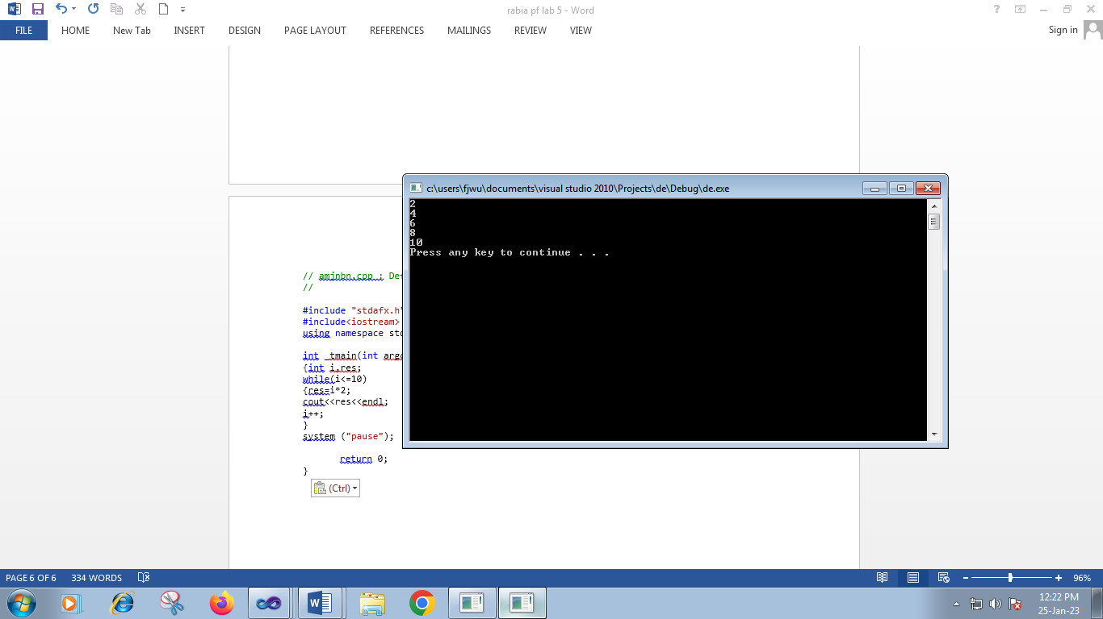

**Task # 6**

// enu.cpp : Defines the entry point for the console application.

//

#include "stdafx.h"

#include<iostream>

using namespace std;

int _tmain(int argc, _TCHAR* argv[])

{

cout<<"use of do while"<<endl;

int i=1,x,res;

cout<<"enter a number"<<endl;

cin>>x;

do

{res=x*i;

cout<<x<<"*"<<i<<"="<<res<<endl;

i++;

}while(i<=10);

system ("pause");

return 0;

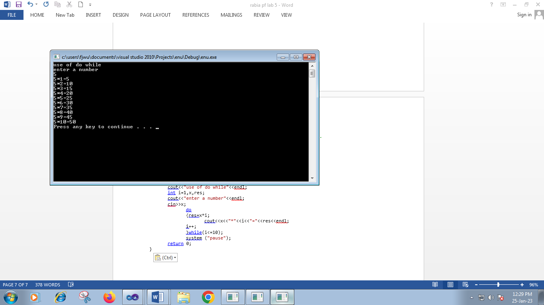

**LAB #6**

TASK 1

// SGWYWET.cpp : Defines the entry point for the console application.

//

#include "stdafx.h"

#include<iostream>

using namespace std;

int _tmain(int argc, _TCHAR* argv[])

{cout<<"use of for loop"<<endl;

int i;

for(i=0;i<10;i++)

{

cout<<i<<endl;

}

system("pause");

return 0;

}

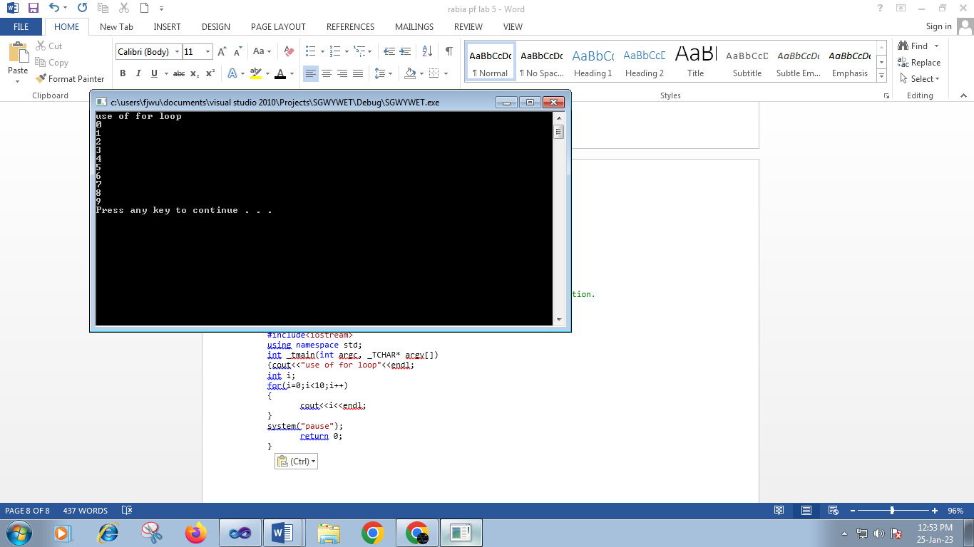

// SGWYWET.cpp : Defines the entry point for the console application.

//

#include "stdafx.h"

#include<iostream>

using namespace std;

int _tmain(int argc, _TCHAR* argv[])

{cout<<"use of for nested loop"<<endl;

int i,j;

for(i=1;i<=4;i++)

{for(j=1;j<=3;j++)

{

cout<<i<<"\t"<<endl;

}

}

system("pause");

return 0;

}

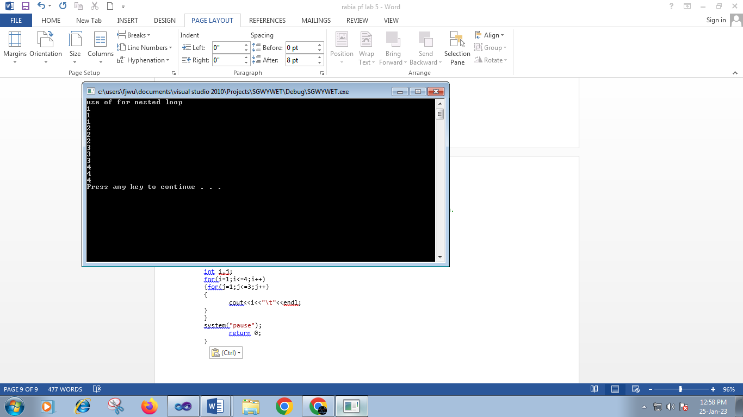

// SGWYWET.cpp : Defines the entry point for the console application.

//

#include "stdafx.h"

#include<iostream>

using namespace std;

int _tmain(int argc, _TCHAR* argv[])

{cout<<"use of for nested loop"<<endl;

int i,n,count=0;

cout<<"enter a num"<<endl;

cin>>n;

for(i=2;i<=n;i++)

{if(n%i==0)

{

count=1;

break;

}

}

if(count==0)

cout<<"this is prime num"<<endl;

else

cout<<"this is not prime num"<<endl;

system("pause");

return 0;

}

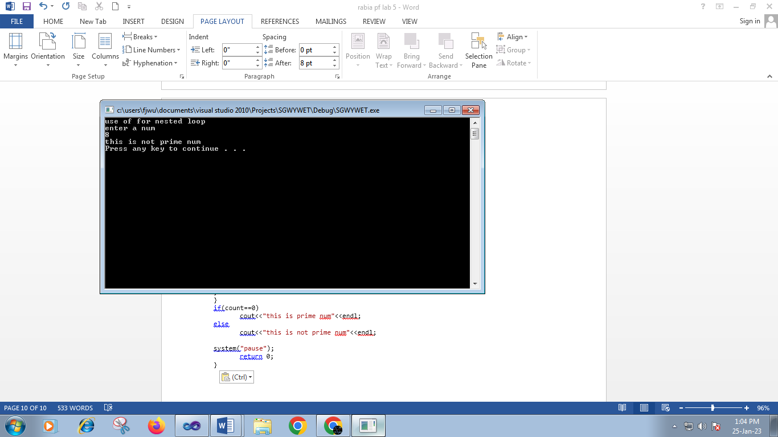

**Task#2**

// SGWYWET.cpp : Defines the entry point for the console application.

//

#include "stdafx.h"

#include<iostream>

using namespace std;

int _tmain(int argc, _TCHAR* argv[])

{int i,x,j,res;

cout<<"enter a num "<<endl;

cin>>x;

cout<<"enter table upto"<<endl;

cin>>j;

for(i=1;i<=j;i++)

{

res=i*x;

cout<<x<<"*"<<i<<"=="<<res<<endl;

}

system("pause");

return 0;

}

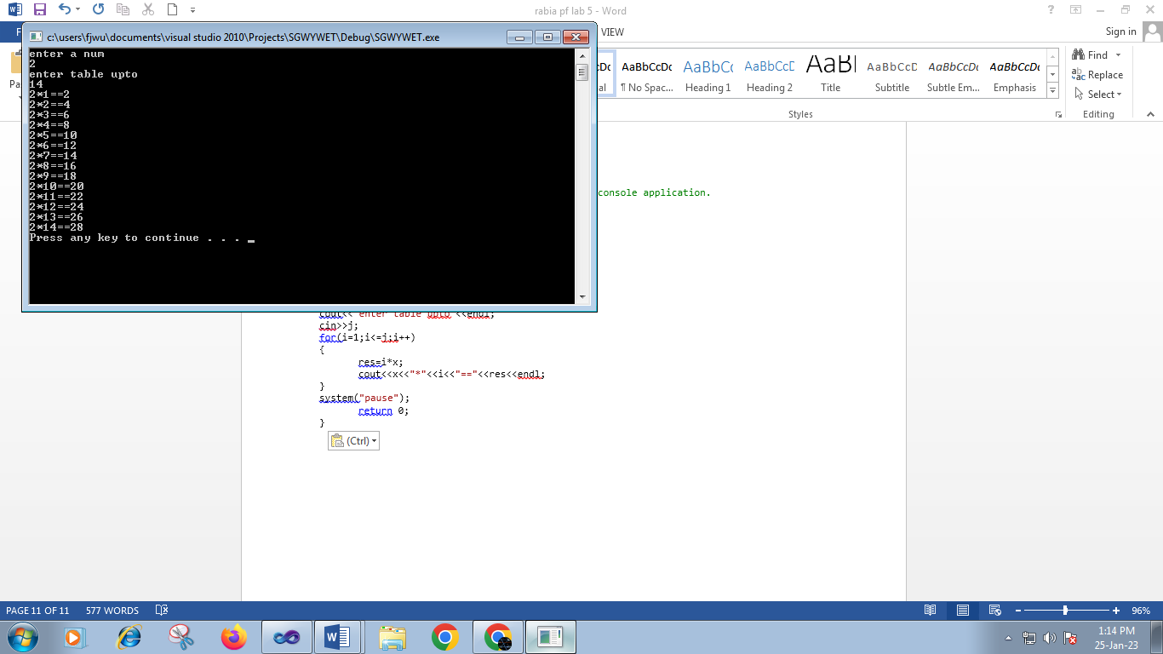

**Task #3**

// SGWYWET.cpp : Defines the entry point for the console application.

//

#include "stdafx.h"

#include<iostream>

using namespace std;

int _ return 0;

}

tmain(int argc, _TCHAR* argv[])

{int i,res=0;

for(i=1;i<=50;i++)

{

res=res+i;

}

cout<<res<<endl;

system("pause");

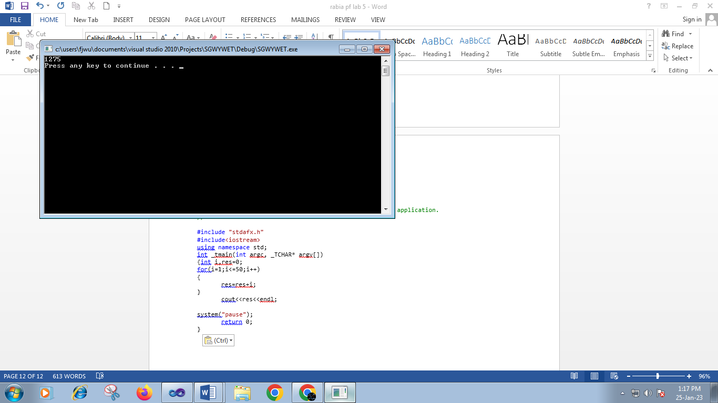

**Task #4**

// SGWYWET.cpp : Defines the entry point for the console application.

//

#include "stdafx.h"

#include<iostream>

using namespace std;

int _tmain(int argc, _TCHAR* argv[])

{

for(int j=1;j<=5;j++)

{

for(int i=1;i<=j;i++)

cout<<"*";

cout<<endl;

}

system("pause");

return 0;

}

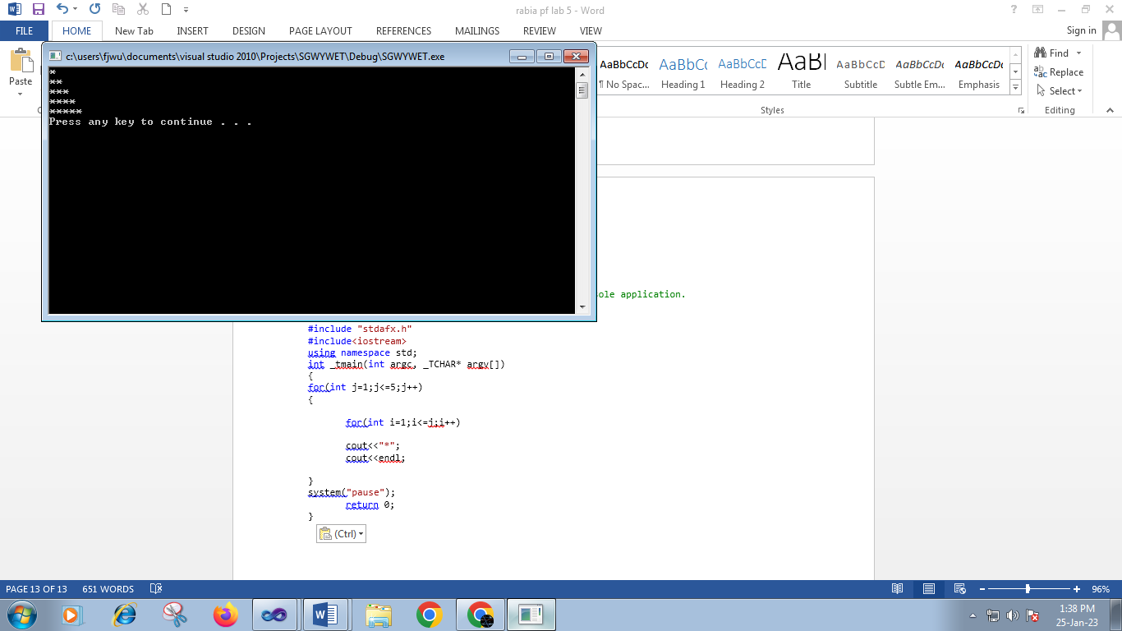

***Task#5***

// SGWYWET.cpp : Defines the entry point for the console application.

//

#include "stdafx.h"

#include<iostream>

using namespace std;

int _tmain(int argc, _TCHAR* argv[])

{

int n=0,np=0,nn=0,nz=0;

for(int i= 1;i<=10;i++)

{

cout<<"enter a num"<<endl;

cin>>n;

if(n<0)

nn++;

else if (n>0)

np++;

else if (n==0)

nz++;

}

cout<<"number of positive values;"<<np<<endl;

cout<<"number of negative values;"<<nn<<endl;

cout<<"number of zero values;"<<nz<<endl;

system("pause");

return 0;

}

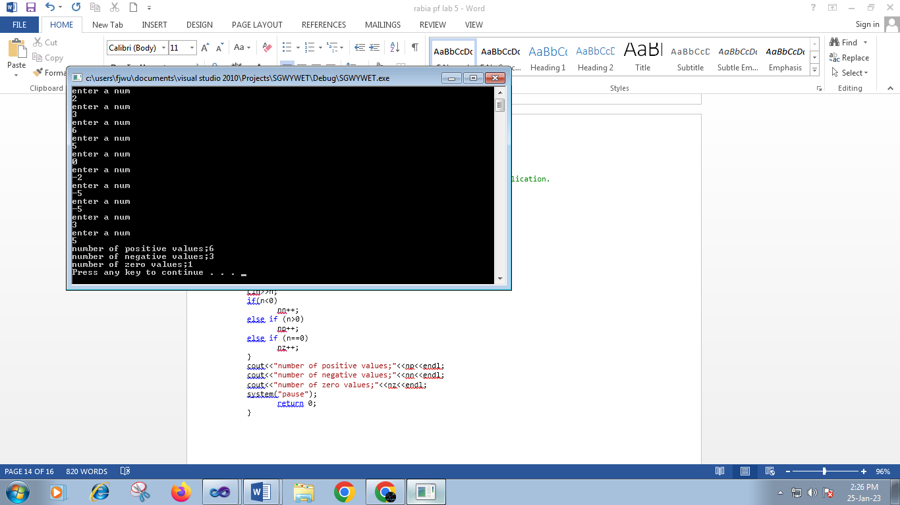Task #6

**Task #6**

// SGWYWET.cpp : Defines the entry point for the console application.

//

#include "stdafx.h"

#include<iostream>

using namespace std;

int _tmain(int argc, _TCHAR* argv[])

{

char c;

cout << "Enter a character: ";

cin >> c;

cout << "ASCII Value of " << c << " is " << int(c);

system("pause");

return 0;

}

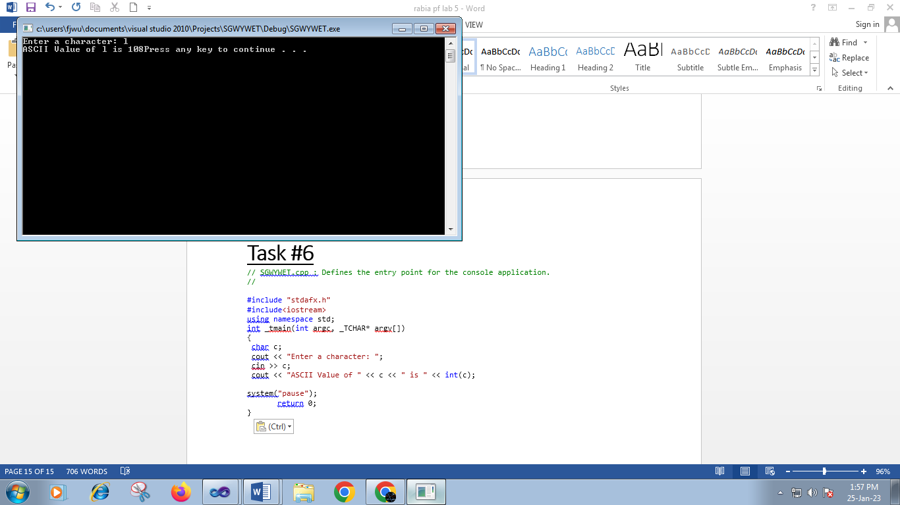

**Task #7**

// SGWYWET.cpp : Defines the entry point for the console application.

//

#include "stdafx.h"

#include<iostream>

using namespace std;

int _tmain(int argc, _TCHAR* argv[])

{

int i,a,b,c,res;

cout<<"enter a num"<<endl;

cin>>i;

cout<<"a=";

cin>>a;

cout<<"b=";

cin>>b;

cout<<"c=";

cin>>c;

res= (a*a*a)+(b*b*b)+(c*c*c);

if(i=res)

cout<<"you entered amstrong num";

else

cout<<"not amstrong";

system("pause");

return 0;

}

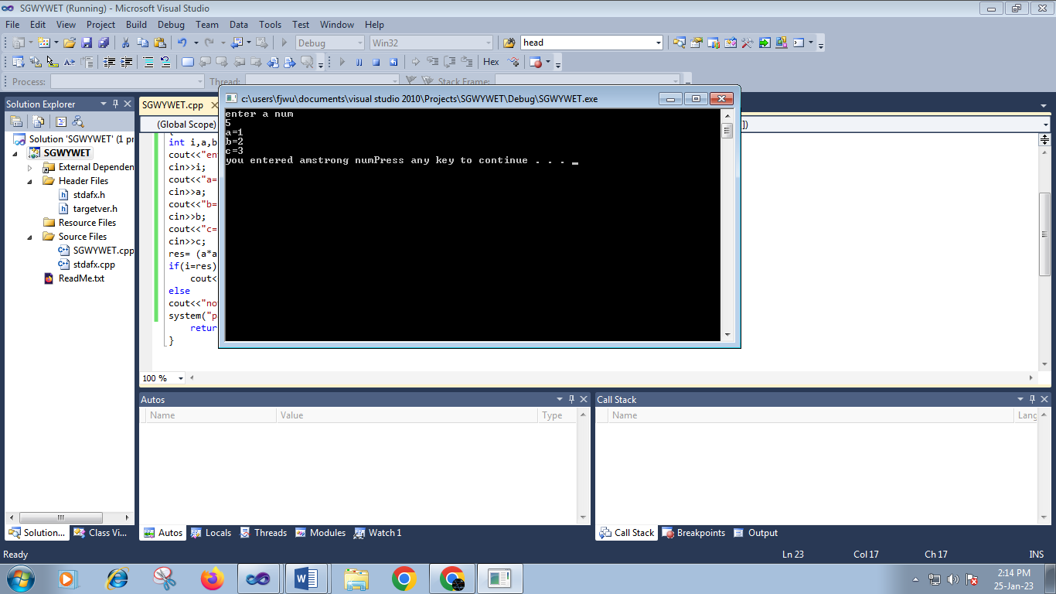

**Lab #7**

**Task #1**

// 147.cpp : Defines the entry point for the console application.

//

#include "stdafx.h"

#include<iostream>;

using namespace std;

int _tmain(int argc, _TCHAR* argv[])

{cout<<"example of arrays"<<endl;

int a[5];

for(int i=0;i<5;i++)

{cout<<"enter a number a"<<i+1<<endl;

cin>>a[i];

}cout<<"you have entered the following value"<<endl;

for(int j=0;j<5;j++)

{cout<<a[j]<<endl;}

system("pause");

return 0;

}

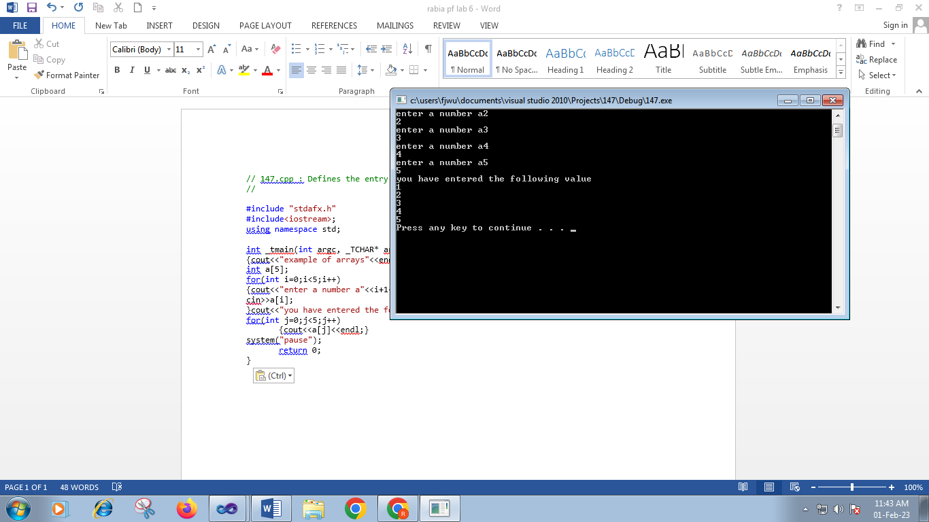

// 147.cpp : Defines the entry point for the console application.

//

#include "stdafx.h"

#include<iostream>;

using namespace std;

int _tmain(int argc, _TCHAR* argv[])

{

int ave,sum=0,i;

int marks[10];

for(int i=0;i<10;i++)

{cout<<"enter marks"<<endl;

cin>>marks[i];}

for(int i=0;i<5;i++)

sum=sum+marks[i];

ave=sum/10;

{cout<<"average ="<<ave<<endl;}

system("pause");

return 0;

}

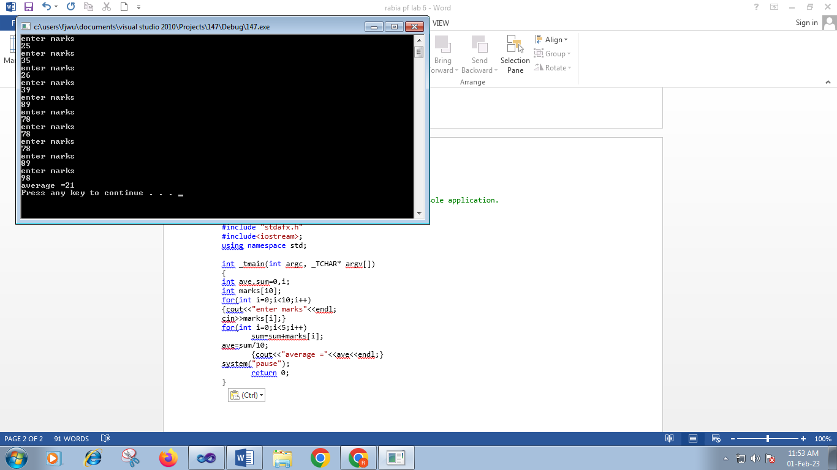

**Task #2**

// 147.cpp : Defines the entry point for the console application.

//

#include "stdafx.h"

#include<iostream>;

using namespace std;

int _tmain(int argc, _TCHAR* argv[])

{

int key ,c=0 ;

int a[15];

cout<<"enter key"<<endl;

cin>>key;

for( int i=0;i<=14;i++)

{cout<<"enter"<<"numbers"<<endl;

cin>>a[i];

}

if(a[15]==key)

{cout<<c++;

cout<<"total same values"<<c<<endl;}

else

cout<<"it is not present"<<endl;

system("pause");

return 0;

}

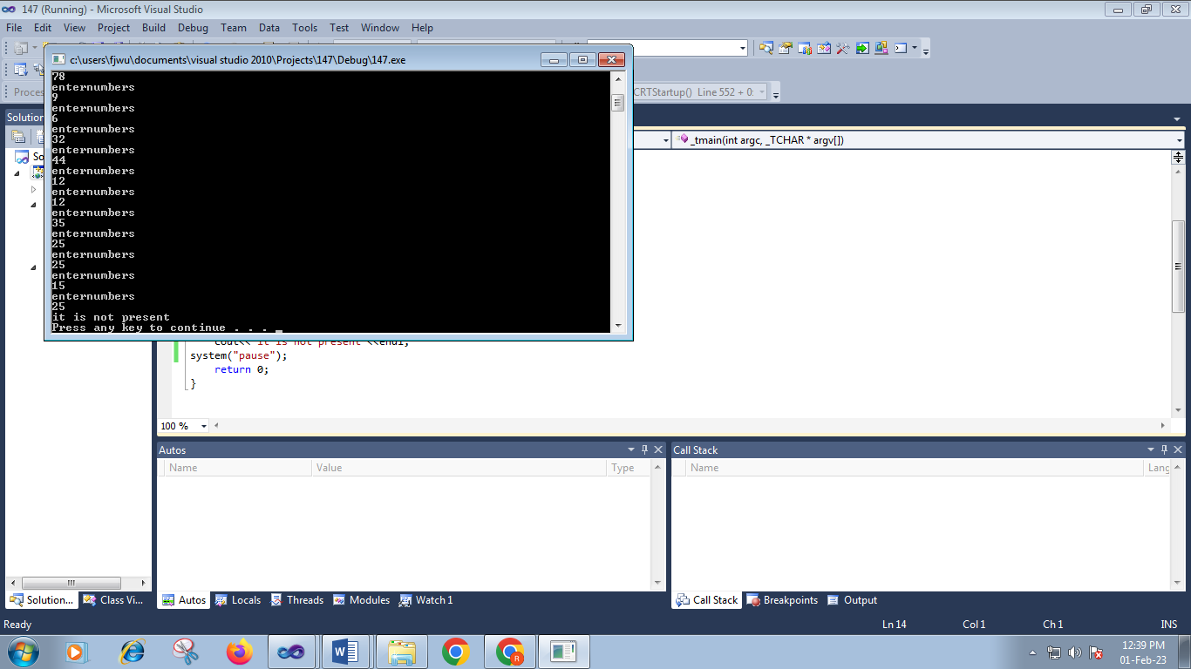

**Task #3**

// gsdgfd.cpp : Defines the entry point for the console application.

//

#include "stdafx.h"

#include<iostream>

using namespace std;

int _tmain(int argc, _TCHAR* argv[])

{int np=0,nn=0,nz=0;

int a[13];

cout<<"enter number"<<endl;

for(int i=0;i<=13;i++)

{

cin>>a[i];

if(a[i]>0){

np++;}

else if (a[i]==0){

nz++;}

else (a[i]<0){

nn++;}

}

cout<<"negative numbers"<<nn<<endl;

cout<<"positive numbers"<< np<<endl;

cout<<"zero"<<nz<<endl;

system("pause");

return 0;

}

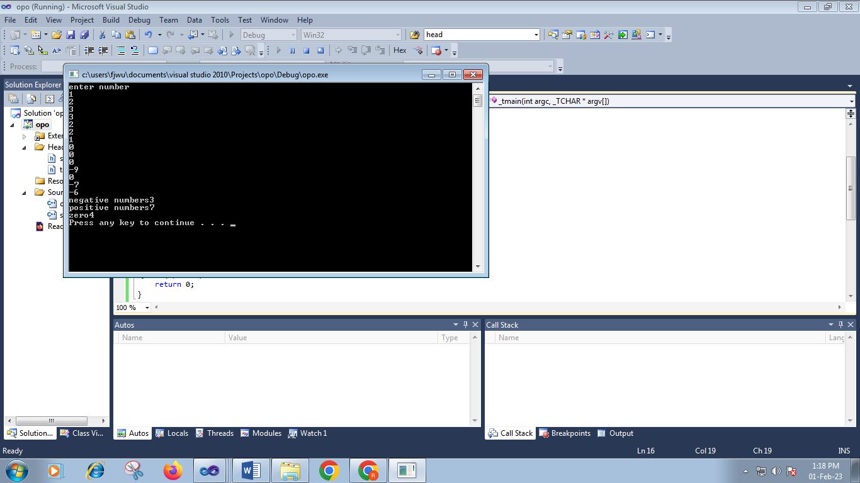

**Task #4**

// 147.cpp : Defines the entry point for the console application.

//

#include "stdafx.h"

#include<iostream>;

using namespace std;

int _tmain(int argc, _TCHAR* argv[])

{int largest=0;

int arr[5];

cout<<"enter 5 numbers"<<endl;

for(int i=0;i<5;i++)

{cin>>arr[i];

if(arr[i]>largest){

largest=arr[i];

}

}

cout<<"the largest is="<<largest<<endl;

system("pause");

return 0;

}

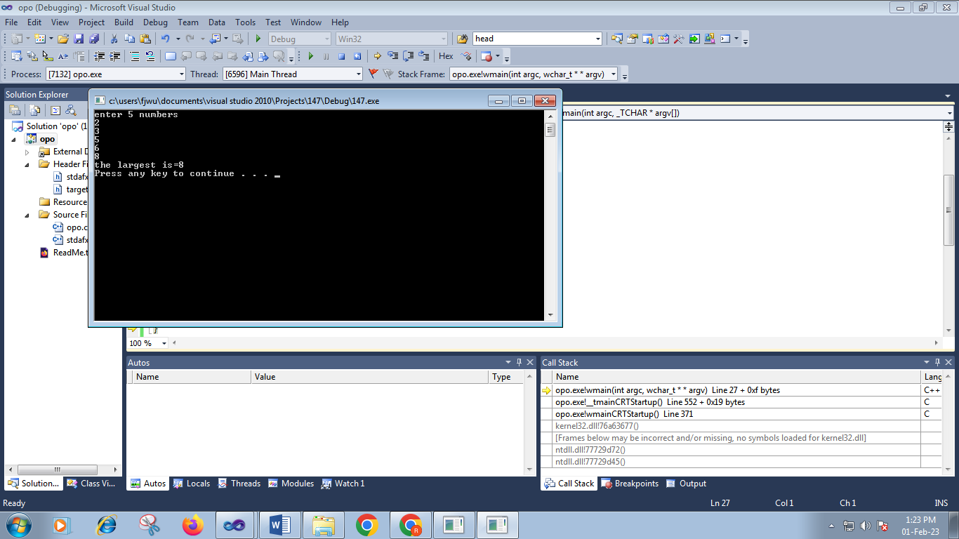

**Task #5**

// 147.cpp : Defines the entry point for the console application.

//

#include "stdafx.h"

#include<iostream>;

using namespace std;

int _tmain(int argc, _TCHAR* argv[])

{int arr[20];

int arr1[10];

int arr2[10];

cout<<"enter 20 numbers"<<endl;

for(int i=0;i<20;i++)

{cin>>arr[i];

}

for(int i=0;i<10;i++)

{arr1[i]=arr[i];

arr2[i]=arr[i +10];

}

cout<<"array =1";

for(int i=0;i<10;i++){

cout<<arr1[i]<<" ";

}cout<<endl;

cout<<"array =2";

for(int i=0;i<10;i++){

cout<<arr2[i]<<" ";}

cout<<endl;

system("pause");

return 0;

}

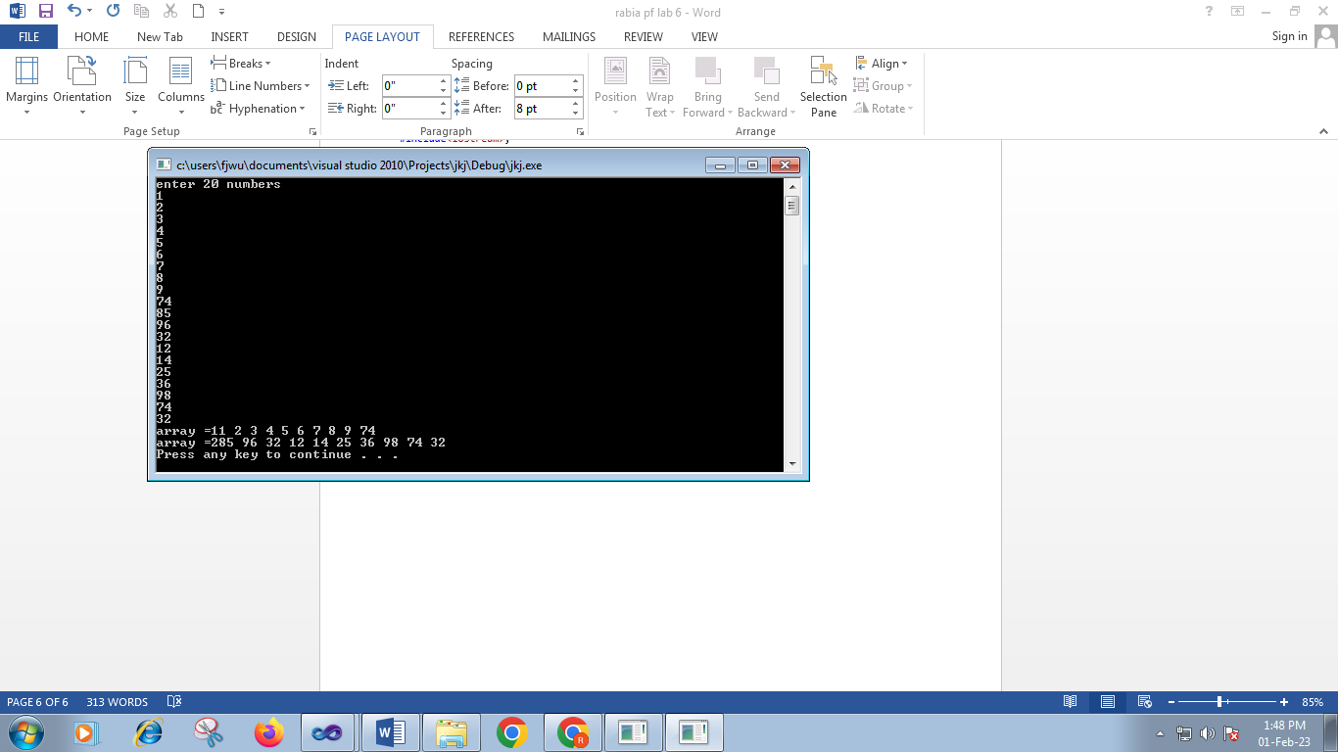

**LAB #8**

# **Task#1;**

// klkl.cpp : Defines the entry point for the console application.

//

#include "stdafx.h"

#include<iostream>

using namespace std;

int main()

{int A[2][3];

for(int i=0;i<2;i++)

{

for(int j=0;j<3;j++)

{cout<<"enter value at index \t"<<i<<j<<endl;

cin>>A[i][j];

}}

for(int w=0;w<2;w++)

{

for(int x=0;x<3;x++)

{cout<<"\t"<<A[w][x];

}}

cout<<endl;

system("pause");

return 0;

}

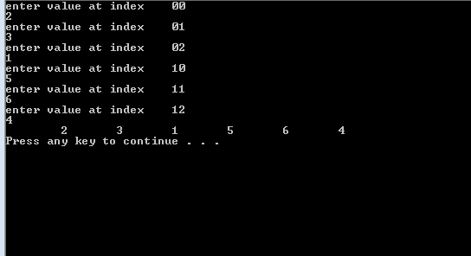

# **Task#2;**

#include<iostream>

using namespace std;

int main()

{

int mat1[3][3], mat2[3][3], i, j, mat3[3][3];

cout<<"Enter Elements of First Matrix: ";

for(i=0; i<3; i++)

{

for(j=0; j<3; j++)

{ cin>>mat1[i][j];}

}

cout<<"Enter Elements of Second Matrix: ";

for(i=0; i<3; i++)

{

for(j=0; j<3; j++)

{ cin>>mat2[i][j];}

}

cout<<"\nAdding the Two Given Matrix...\n";

for(i=0; i<3; i++)

{

for(j=0; j<3; j++)

{ mat3[i][j] = mat1[i][j]+mat2[i][j];}

}

cout<<"Addition Result of Two Given Matrix is:\n";

for(i=0; i<3; i++)

{

for(j=0; j<3; j++)

{ cout<<mat3[i][j]<<" ";

cout<<endl;}

}

system("pause");

return 0;

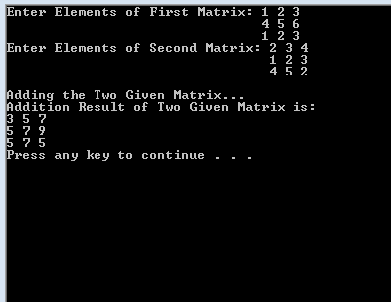

**Task #3**

#include<iostream>

using namespace std;

int main()

{

int mat1[6][6], mat2[6][6], i, j, mat3[6][6];

cout<<"Enter Elements of First Matrix: ";

for(i=0; i<6; i++)

{

for(j=0; j<6; j++)

{ cin>>mat1[i][j];}

}

cout<<"Enter Elements of Second Matrix: ";

for(i=0; i<6; i++)

{

for(j=0; j<6; j++)

{ cin>>mat2[i][j];}

}

cout<<"\nAdding the Two Given Matrix...\n";

for(i=0; i<6; i++)

{

for(j=0; j<6; j++)

{ mat3[i][j] = mat1[i][j]-mat2[i][j];}

}

cout<<"Addition Result of Two Given Matrix is:\n";

for(i=0; i<6; i++)

{

for(j=0; j<6; j++)

{ cout<<mat3[i][j]<<" ";

cout<<endl;}

}

system("pause");

return 0;

}

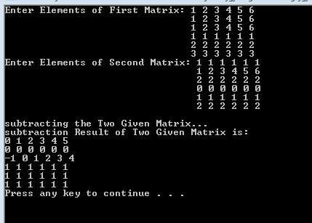

**Task#4**

// 2010.cpp : Defines the entry point for the console application.

//

#include "stdafx.h"

#include<iostream>

using namespace std;

int _tmain(int argc, _TCHAR* argv[])

{int array[3][2][2];

cout<<"enter 12 values";

for(int i=0;i<3;i++)

{for(int j=0;j<2;j++)

{ for(int k=0;k<2;k++)

{cin>>array[i][j][k];

}

}

}

cout<<"below the values you have stored in array"<<endl;

for(int i=0;i<3;i++)

{for(int j=0;j<2;j++)

{ for(int k=0;k<2;k++)

cout<<"["<<i<<"]"<<"["<<j<<"["<<k<<"["<<"]"<<array[i][j][k]<<endl;

}

}

system("pause");

return 0;

}

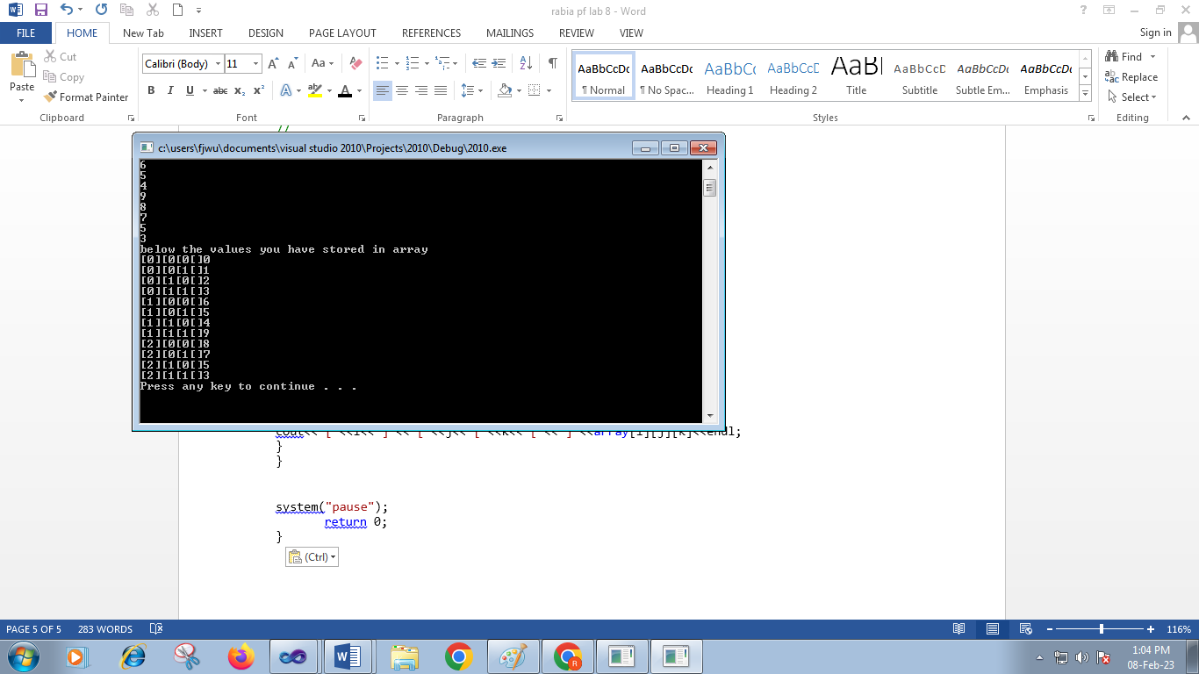

**LAB #9**

**Task 1:**

Sample 1:

#include "stdafx.h"

#include<iostream>

using namespace std;

void print(); // function declaration

void print() // function definition

{

cout<<"i am in function"<<endl;

}

int _tmain(int argc, _TCHAR* argv[])

{ print();

system("pause");

return 0;

}

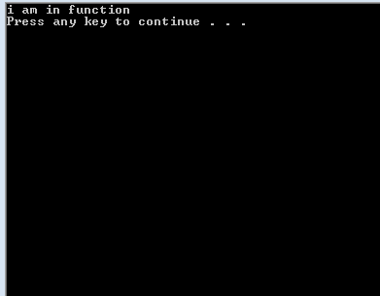

#include "stdafx.h"

#include<iostream>

using namespace std;

int sum(int,int); // function declaration

int sum(int x,int y) // function definition

{

return x+y;

}

int _tmain(int argc, _TCHAR* argv[])

{ int a=10;

int b=20;

int z;

z= sum(a,b); //function calling

cout<<z;

system("pause");

return 0;

}

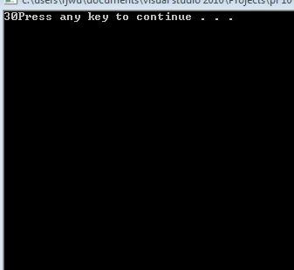

#include "stdafx.h"

#include<iostream>

using namespace std;

int sub(int x,int y)

{ int z;

z=x-y;

return z; }

int _tmain(int argc, _TCHAR* argv[])

{

int a=20,b=10,c=5,d,e,f;

d=sub(a,b);

cout<<"result of first subtraction is "<<d<<endl;

e=sub(20,10);

cout<<"result of second subtraction is "<<e<<endl;

cout<<"result of third subtraction is "<<sub(20,10)<<endl;

f=10+sub(a,10);

cout<<"10 + result of subtraction is " <<f<<endl;

system("pause");

return 0;

}

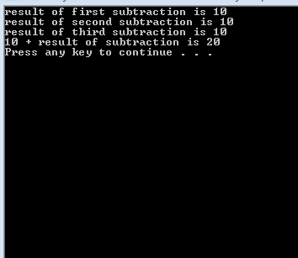

**Task#2:**

**Give answers to the following:**

1. **Write the declartion of a function named: power, to compute x^n.**

Void _power(x ,n )

1. **Call the function: int factorial(int) ;**

factorial(a);

**3. Which of these are valid function declarations:**

**A void function();**

**B void function(void);**

**C void function(int);**

**D function(int);**

**E int function();**

A ,b ,c ,e are valid

**Task 2 :**

**Write the output of the following code fragments.**

1. int square(int);

int main()

{

for(int i=0;i&lt;10;i+=2)

cout &lt;&lt; square(i) &lt;&lt; endl;

return 0;

}

int square(int a)

{

return a*a;

}

**Output:**

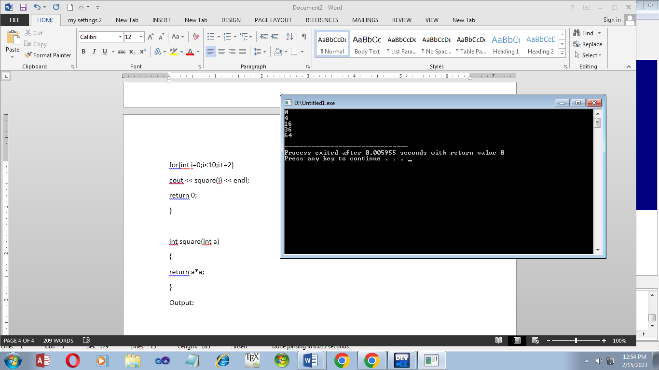

2. int minimum(int,int);

int main()

{

int x=10,y=5;

int m = minimum(x,y);

cout&lt;&lt;m&lt;&lt;endl;

return 0;

}

int minimum(int a,int b)

{

if (a&lt;b)

return a;

else

return b;

}

**Output:**

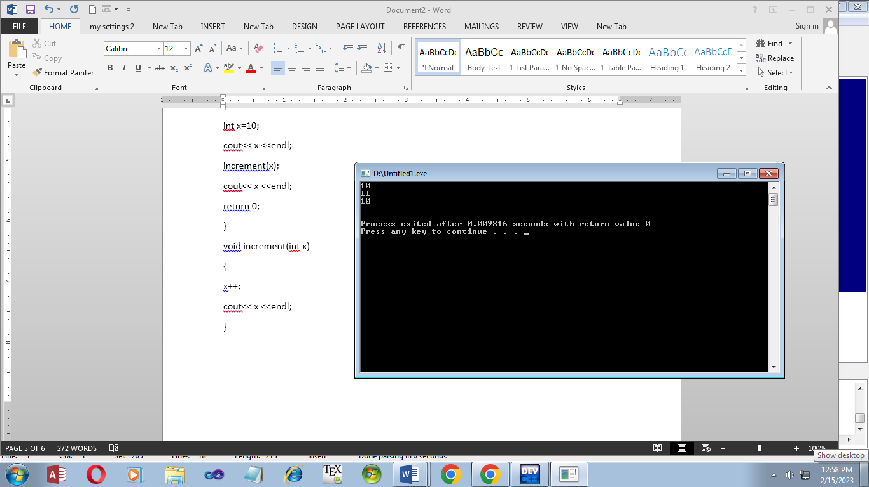

3. void increment(int);

int main()

{

int x=10;

cout&lt;&lt; x &lt;&lt;endl;

increment(x);

cout&lt;&lt; x &lt;&lt;endl;

return 0;

}

void increment(int x)

{

x++;

cout&lt;&lt; x &lt;&lt;endl;

**output:**

}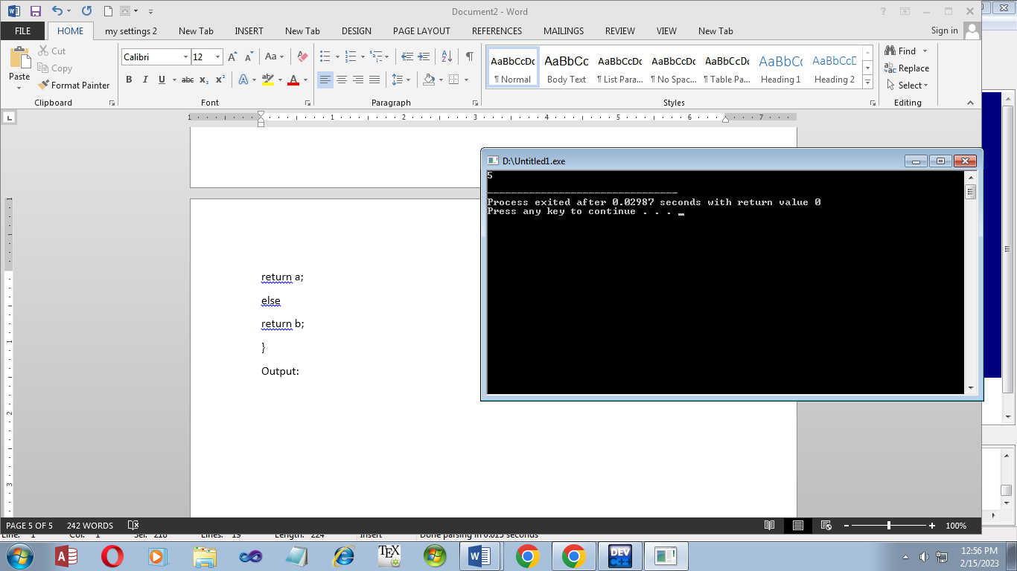

**Task#3:**

**Create a function which display your Name , Reg no, Class, Section.**

**Display all the things within the body of function, call the function in main**.

// lkj.cpp : Defines the entry point for the console application.

//

#include "stdafx.h"

#include<iostream>

using namespace std;

void display();

int _tmain(int argc, _TCHAR* argv[])

{

display();

system("pause");

return 0;

}

void display()

{

cout<<"my name is rabia"<<endl;

cout<<"reg= 064"<<endl;

cout<<"age =18"<<endl;

cout<<"class=BSE I-B"<<endl;

}

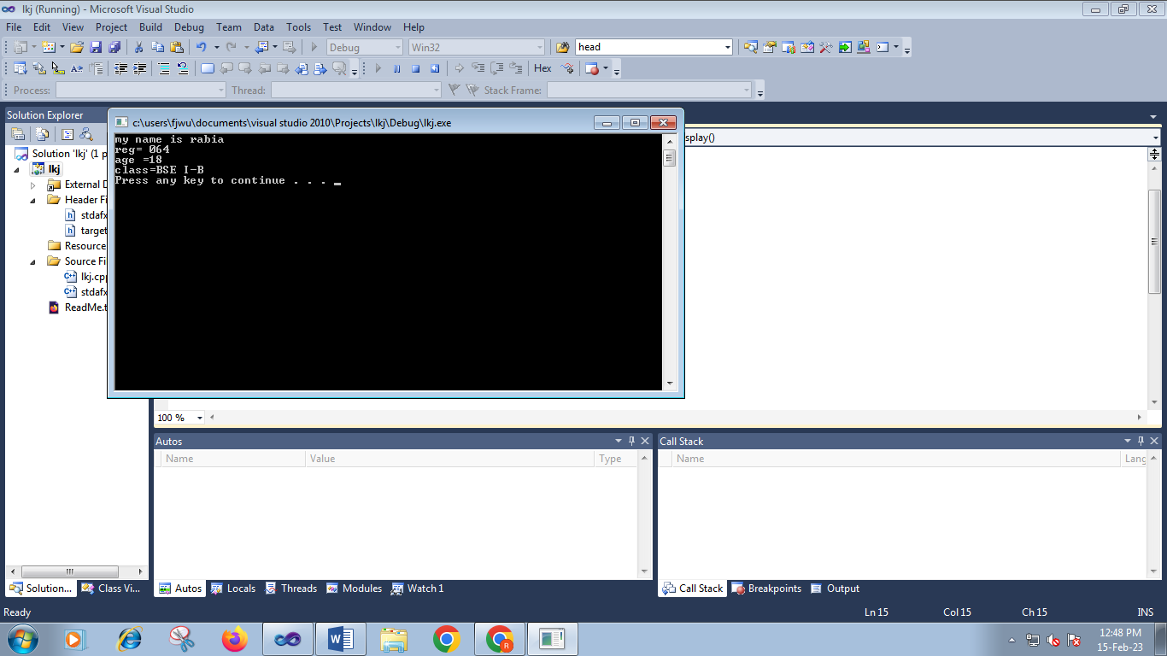

**Task#4:**

**Create a function SUM in C++ which calculates and return the sum of 5 numbers entered by user.**

// lkj.cpp : Defines the entry point for the console application.

//

#include "stdafx.h"

#include<iostream>

using namespace std;

int sum(int,int,int,int,int);

int _tmain(int argc, _TCHAR* argv[])

{

int a,b,c,d,e,s;

cout<<"enter five numbers"<<endl;

cin>>a;

cin>>b;

cin>>c;

cin>>d;

cin>>e;

s = sum(a,b,c,d,e);

cout<<"sum of five numbers = "<<s<<endl;

system("pause");

return 0;

}

int sum(int k,int l ,int m,int n,int o)

{

int sum=0;

sum=k+l+m+n+o;

return sum;

}

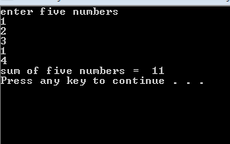

**Task#5:**

**Create a function is_even which take a number as argument, return TRUE if number is even.**

**Take number from user at run time.**

// lkj.cpp : Defines the entry point for the console application.

//

#include "stdafx.h"

#include<iostream>

using namespace std;

int even(int);

int _tmain(int argc, _TCHAR* argv[])

{

int a,s;

cout<<"enter a number"<<endl;

cin>>a;

s = even(a);

cout<<"number="<<s<<endl;

cout<<"we know 1 means true and 0 means false"<<endl;

system("pause");

return 0;

}

bool b1= true;

bool b2=false;

int even(int k)

{

if( k%2==0)

return b1;

else

return b2;

}

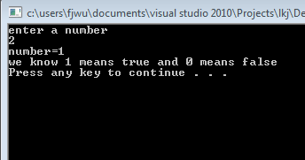

Lab#10:

Task#1:

Compile all sample programs

#include "stdafx.h"

#include<iostream>

using namespace std;

void duplicate (int& a, int& b, int& c)

{

a=a*2;

b=b*2;

c=c*2;

}

int _tmain(int argc, _TCHAR* argv[])

{

int x=1, y=3, z=7;

duplicate (x, y, z);

cout << "x=" << x << ", y=" << y << ", z=" << z;

system("pause");

return 0;

}

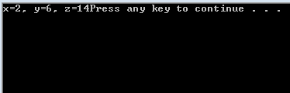

#include "stdafx.h"

#include<iostream>

using namespace std;

void prevnext (int x, int& prev, int& next)

{

prev = x-1;

next = x+1;

}

int _tmain(int argc, _TCHAR* argv[])

{

int x=100, y, z;

prevnext (x, y, z);

cout << "Previous=" << y << ", Next=" << z;

system("pause");

return 0;

}

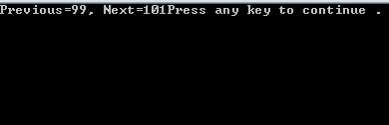

#include "stdafx.h"

#include<iostream>

using namespace std;

int divide (int a, int b=2)

{

int r;

r=a/b;

return r;

}

int _tmain(int argc, _TCHAR* argv[])

{

cout << divide (12);

cout << endl;

cout << divide (20,4);

system("pause");

return 0;

}

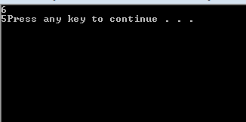

#include "stdafx.h"

#include<iostream>

using namespace std;

int operate (int a, int b)

{

return a*b;

}

float operate (float a, float b)

{

return a/b;

}

int _tmain(int argc, _TCHAR* argv[])

{

int x=5,y=2;

float n=5.0,m=2.0;

cout << operate (x,y);

cout << "\n";

cout << operate (n,m);

cout << "\n";

system("pause");

return 0;

}

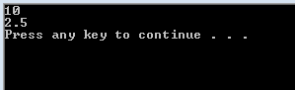

#include "stdafx.h"

#include<iostream>

using namespace std;

int fact (int a)

{

if (a==0)

return 1;

else

return a*fact(a-1);

}

int _tmain(int argc, _TCHAR* argv[])

{

int n;

cout << "Please type a number: ";

cin >> n;

cout << n << "! = " << fact (n);

system("pause");

return 0;

}

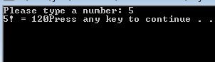

Task#2

Create a program with a function which calculate the square of both the values entered by user. (Using

call be reference)

// njhg.cpp : Defines the entry point for the console application.

//

#include "stdafx.h"

#include<iostream>

using namespace std;

void square(int& a,int& b);

int _tmain(int argc, _TCHAR* argv[])

{int x=5,y=10;

square( x, y);

cout<<"x="<<x<<endl<<"y="<<y<<endl;

system("pause");

return 0;

}

void square(int& a,int& b)

{

a=a*a;

b=b*b;

}

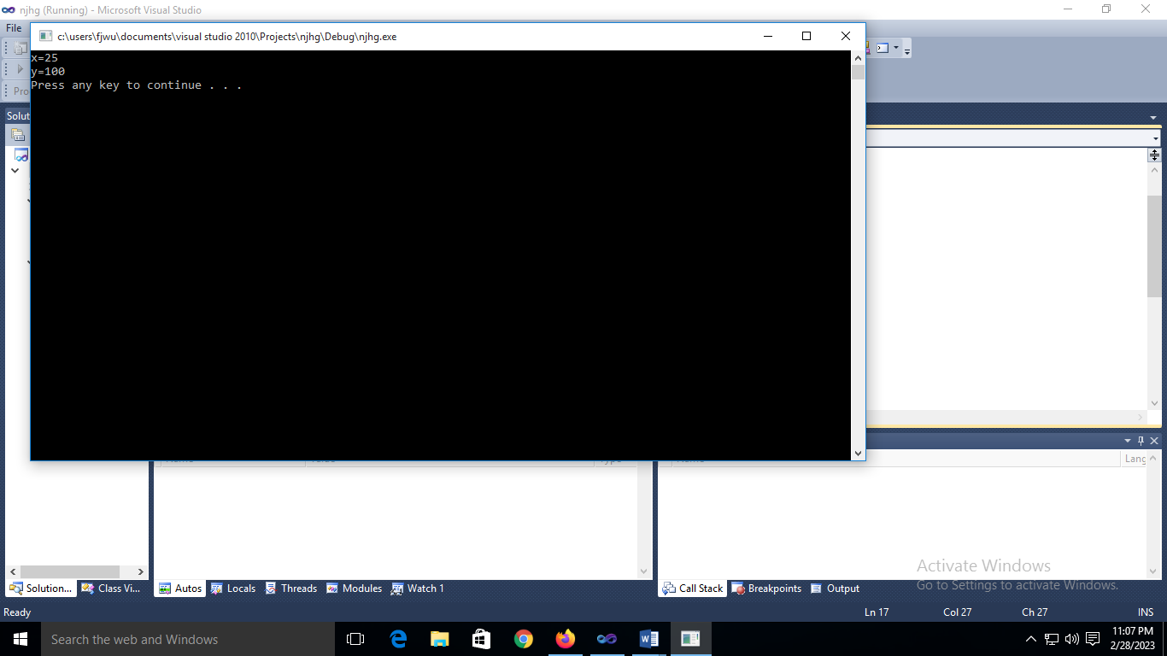

Task #3

Write a program with a function volume( ) to calculate the volume of a cube. Use Function

Overloading concept .Call this function with zero, one, two and three arguments and display the

volume returned in the main( ). Use length of side =1 for definition with no arguments.

v= ,s = length of side

// njhg.cpp : Defines the entry point for the console application.

//

#include "stdafx.h"

#include<iostream>

using namespace std;

int volume();

int volume(int a);

int volume(int a,int b);

int volume(int a,int b,int c);

int _tmain(int argc, _TCHAR* argv[])

{int x=1,y=3,z=4,s;

cout<<"volume of cube wth no argument"<<endl;

s=volume();

cout<<"volume with no argument"<<endl<<s<<endl;

cout<<"volume of cube wth one argument"<<endl;

s= volume(x);

cout<<"volume with one argument"<<endl<<s<<endl;

cout<<"volume of cube wth two argument"<<endl;

s=volume(x,y);

cout<<"volume with two argument"<<endl<<s<<endl;

cout<<"volume of cube wth three argument"<<endl;

s=volume(x,y,z);

cout<<"volume with three argument"<<endl<<s<<endl;

system("pause");

return 0;

}

int volume()

{int s,y=4;

s=y*y*y;

return s;

}

int volume(int a)

{int s;

s=a*a*a*a;

return s;

}

int volume(int a,int b)

{int s;

s=a*a*b*a;

return s;

}

int volume(int a,int b,int c)

{int s;

s=a*a*b*c;

return s;

}

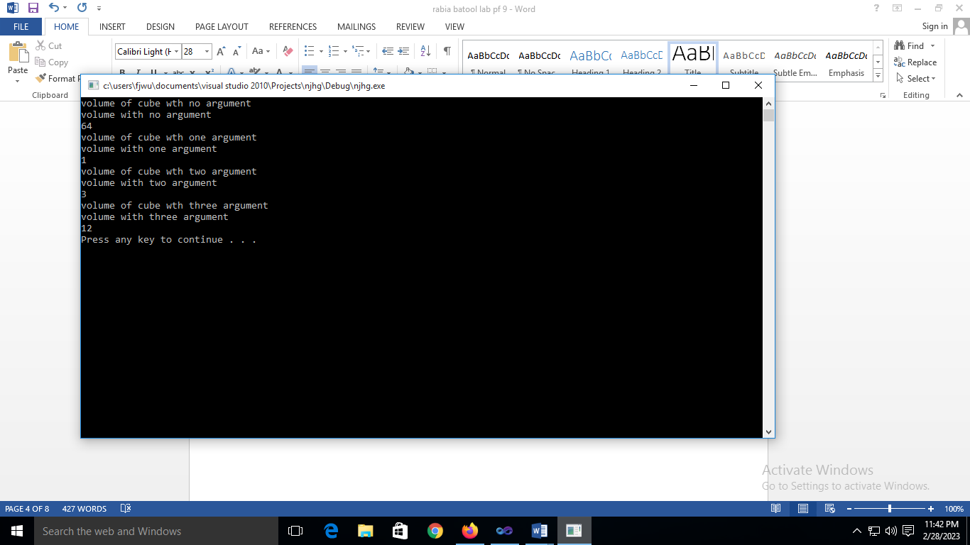

Task#4

**Perform Task # 03 by using Default value concept call the function with 0,1, 2 and 3 Arguments**

#include "stdafx.h"

#include<iostream>

using namespace std;

int vol(int s=5);// default funcion parameter

int _tmain(int argc, _TCHAR* argv[])

{ int s;

cout<<"volume of a cube"<<endl;

cout<<"Enter length of sides=";

cin>>s;// if user not enter a value function will use default parameter

cout<<"volume of cube="<<vol(s);

system ("pause");

return 0;

}

int vol(int s)

{int c=s*s*s;

return c;

}

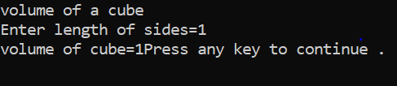

Task 5

int calculatepower(int base,int power);

int main()

{

int base,power,result;

cout<<"Enter base =";

cin>>base;

cout<<"Enter power =";

cin>>power;

result=calculatepower(base,power);

cout<<base<<"^"<<power<<"="<<result;

system ("pause");

return 0;

}

int calculatepower(int base,int power)

{

if(power==0)

return 1;

else

return base*calculatepower(base,power-1);

}

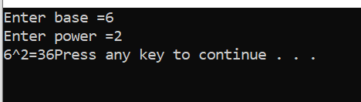

***Lab#11***

TASK #01

// gjuyik.cpp : Defines the entry point for the console application.

//

#include "stdafx.h"

#include< iostream >

using namespace std;

int main()

{

int *p1,*p2; int a=10,b=20; p1=&a; p2=&b;

cout<<" value of a= "<< a;

cout<<" \nvlaue of b= "<< b;

cout<<" \nvalue of p1= "<< p1;

cout<<" \nvalue of p2= "<< p2;

cout<<" \nvalue of &a= "<< &a;

cout<<" \nvalue of &b ="<< &b;

cout<<" \nvalue of *p1 = " <<*p1;

cout<<" \nvalue of *p2 ="<<*p2 ;

system("pause");

}

OUTPUT:

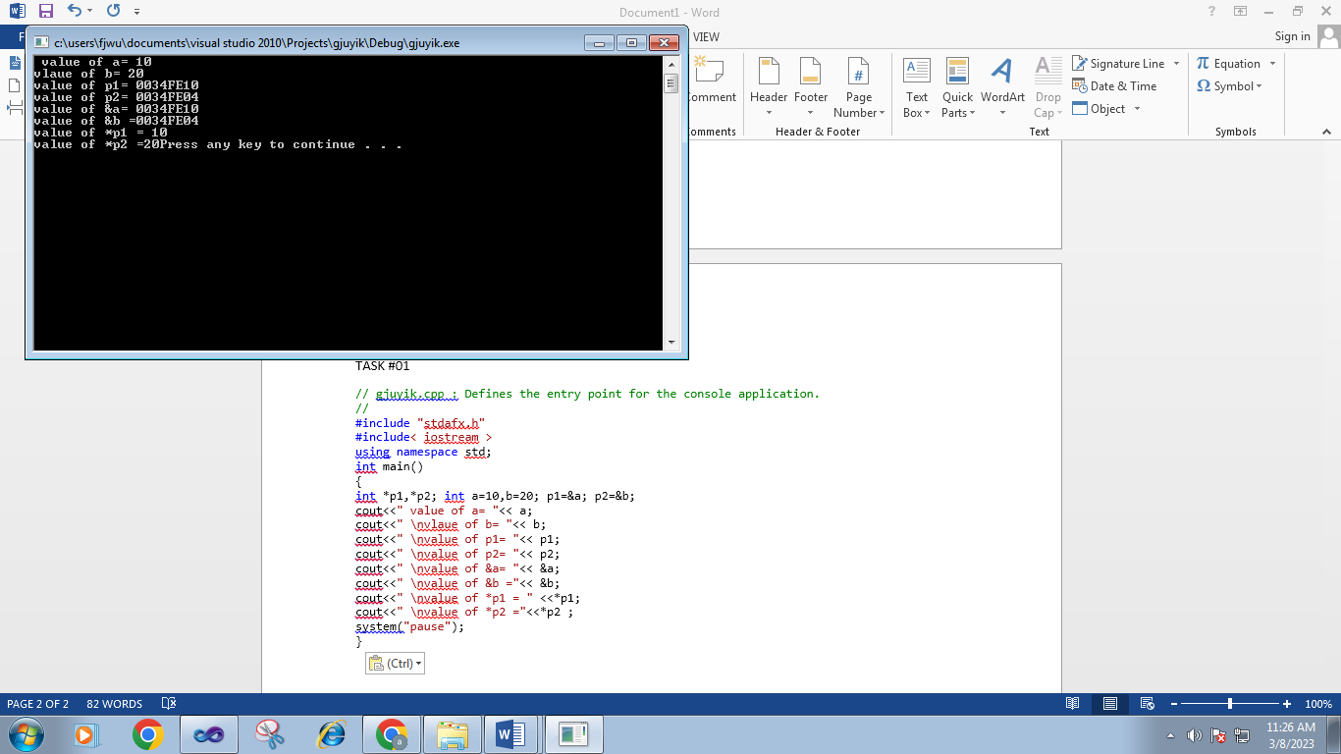

// gjuyik.cpp : Defines the entry point for the console application.

//

#include "stdafx.h"

#include< iostream >

using namespace std;

int main()

{

int a=5,b=10,c,*p1,*p2,*s;

p1=&a; p2=&b; s=&c;

*s=*p1+*p2;

cout<<"addition of values at adress =" <<*s;

system("pause") ;

return 0;

}

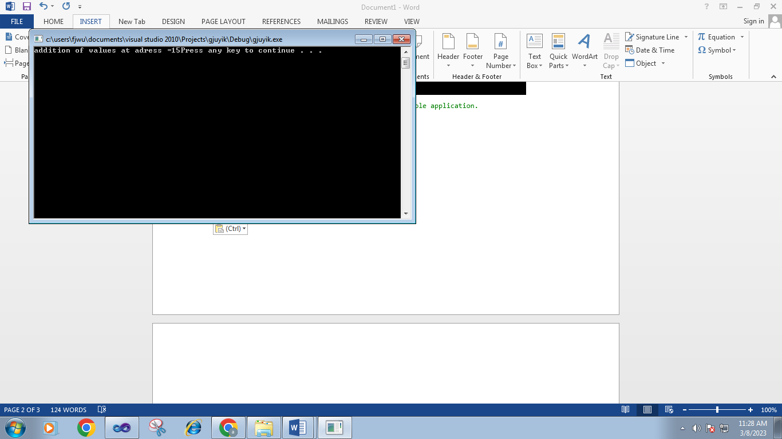

// gjuyik.cpp : Defines the entry point for the console application.

//

#include "stdafx.h"

#include< iostream >

using namespace std;

int main()

{ int i=3,*j,**k; j=&i; k=&j;

cout<<"\n Adress of i = "<< &i;

cout<<"\n Adress of i = "<< j;

cout<<"\n Adress of i = "<< *k;

cout<<"\n Adress of j = "<< &j;

cout<<"\n Adress of j = "<< k;

cout<<"\n Adress of k = "<< &k;

cout<<"\n Value of j = "<< j;

cout<<"\n Value of k = "<< k;

cout<<"\n Value of i = "<< i;

cout<<"\n Value of i = "<<*( &i);

cout<<"\n Value of i = "<< *j;

cout<<"\n Value of i = "<< **k;

system("pause") ;

return 0;

}

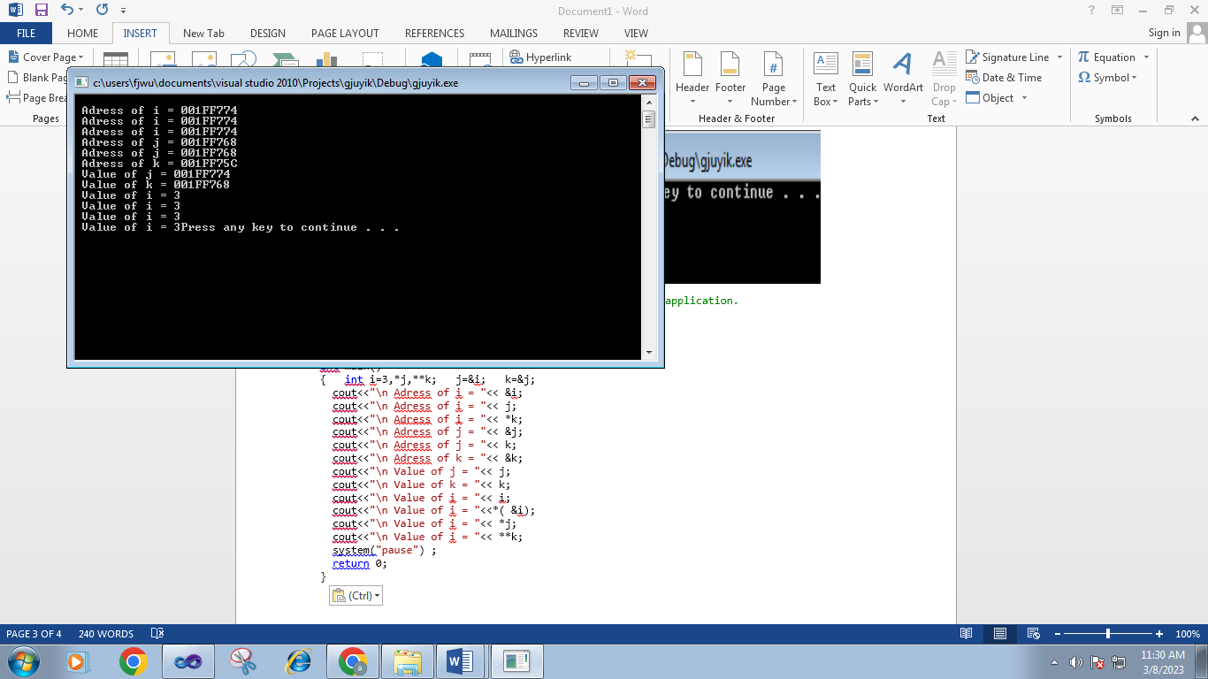

Task#2:

Create a C++ program to find the sum of 5 numbers using pointers

Code:

// 4147.cpp : Defines the entry point for the console application.

//

#include "stdafx.h"

#include<iostream>

using namespace std;

int _tmain(int argc, _TCHAR* argv[])

{int a,b,c,d,e,*ptr1,*ptr2,*ptr3,*ptr4,*ptr5,*s,k;

cout<<"enter the five numbers"<<endl;

cin>>a;

cin>>b;

cin>>c;

cin>>d;

cin>>e;

ptr1=&a;

ptr2=&b;

ptr3=&c;

ptr4=&d;

ptr5=&e;

s=&c;

*s=*ptr1+*ptr2+*ptr3+*ptr4+*ptr5;

cout<<"sum of numbers="<<*s;

system("pause");

return 0;

}

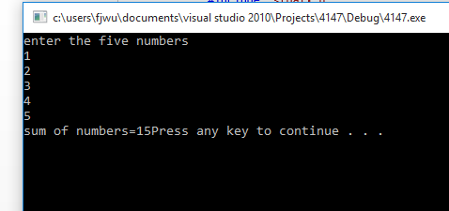

Task#3:

Create a C++ program to swap the values of two variables using pointer notation.

Code:

// 4147.cpp : Defines the entry point for the console application.

//

#include "stdafx.h"

#include<iostream>

using namespace std;

int _tmain(int argc, _TCHAR* argv[])

{int a=10,b=5,c=0,*ptr1,*ptr2,*ptr3;

cout<<"before swaping the two numbers"<<endl<<"a="<<a<<"b="<<b;

ptr1=&a;

ptr2 =&b;

ptr3=&c;

*ptr3=*ptr1;

*ptr1=*ptr2;

*ptr2=*ptr3;

cout<<"after swaping="<<endl<<"a="<<a<<"b="<<b<<endl;

system("pause");

return 0;

}

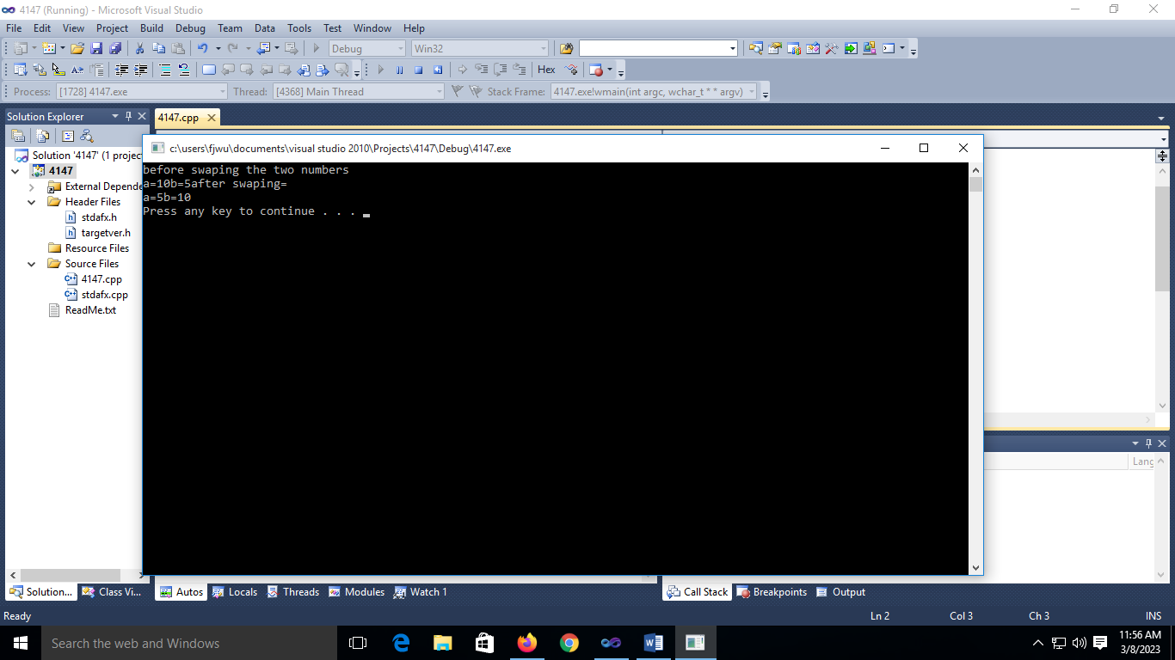

Task#4:

Using the concept of pointer to pointer create a program which add two float values

*(*p1)+*(*p2)

Code:

// 4147.cpp : Defines the entry point for the console application.

//

#include "stdafx.h"

#include<iostream>

using namespace std;

int _tmain(int argc, _TCHAR* argv[])

{float a=10.0,b=5.0,*ptr1,*ptr2,**ptrs1,**ptrs2,*ptrs,s;

cout<<"value the two numbers"<<endl<<"a="<<a<<"b="<<b;

ptr1=&a;

ptr2 =&b;

ptrs =&s;

ptrs1=&ptr1;

ptrs2=&ptr2;

*ptrs=**ptrs1+**ptrs2;

cout<<"sum="<<endl<<*ptrs<<endl;

system("pause");

return 0;

}

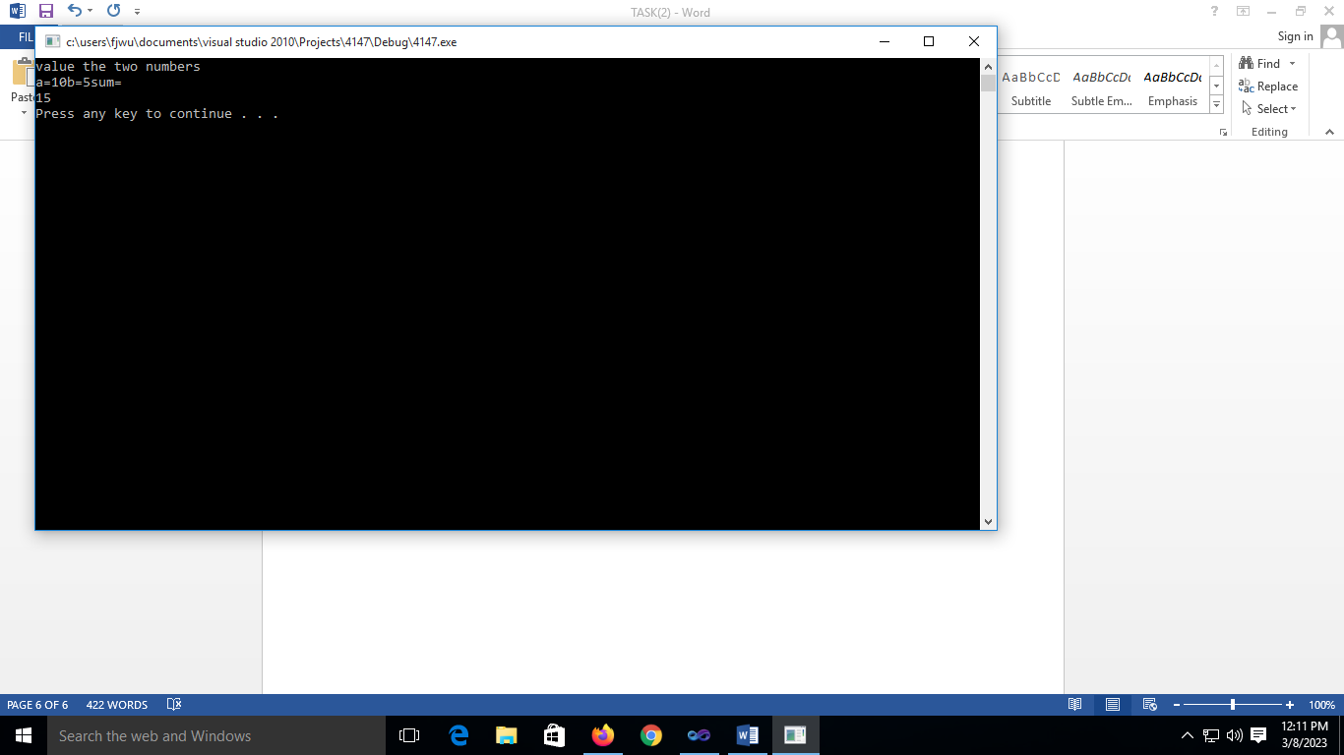

Task#4:

COMPILE a C++ program to find the largest number from the array of 7 numbers using pointer

Code:

// 4147.cpp : Defines the entry point for the console application.

//

#include "stdafx.h"

#include<iostream>

using namespace std;

int _tmain(int argc, _TCHAR* argv[])

{int arr[7],max,*ptr;

ptr=&max;

cout<<" enter value the numbers"<<endl;

for(int i=0;i<7;i++)

{cin>>arr[i];

}max=arr[0];

for(int i=1;i<7;i++)

{if(max<arr[i])

max=arr[i];

}

cout<<"maximum number of array ="<<*ptr<<endl;

system("pause");

return 0;

}

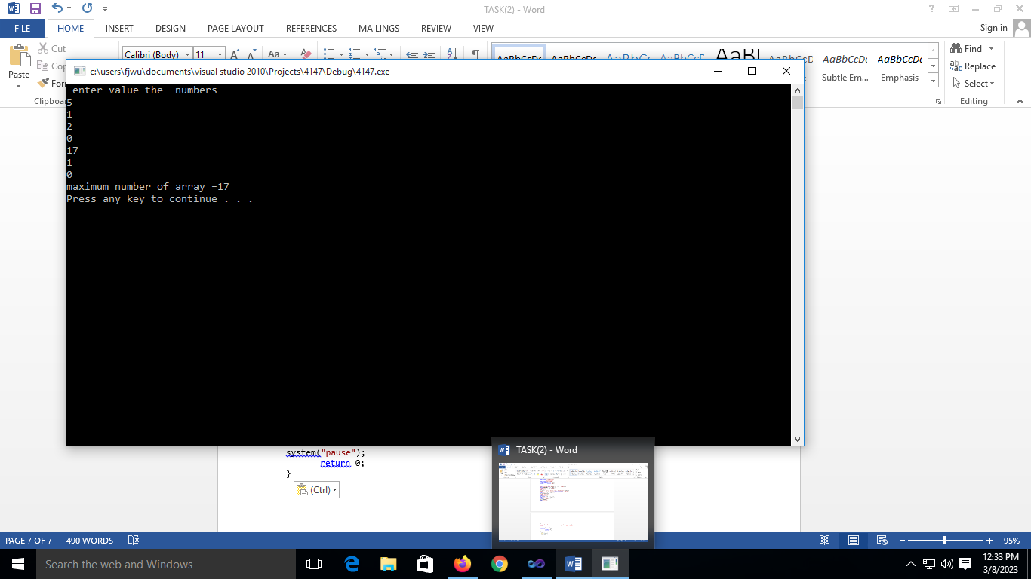

Task#6;

Create a program which print the table of 2 upto 12 using pointers.

Code:

// 4147.cpp : Defines the entry point for the console application.

//

#include "stdafx.h"

#include<iostream>

using namespace std;

int _tmain(int argc, _TCHAR* argv[])

{int tab=2,i,res,*ptrtab,*ptri,*ptrres;

ptrtab=&tab;

ptri=&i;

ptrres=&res;

for(i=1;i<=12;i++)

{res=tab*i;

cout<<*ptrtab<<"*"<<*ptri<<"="<<*ptrres<<endl;

}

system("pause");

return 0;

}

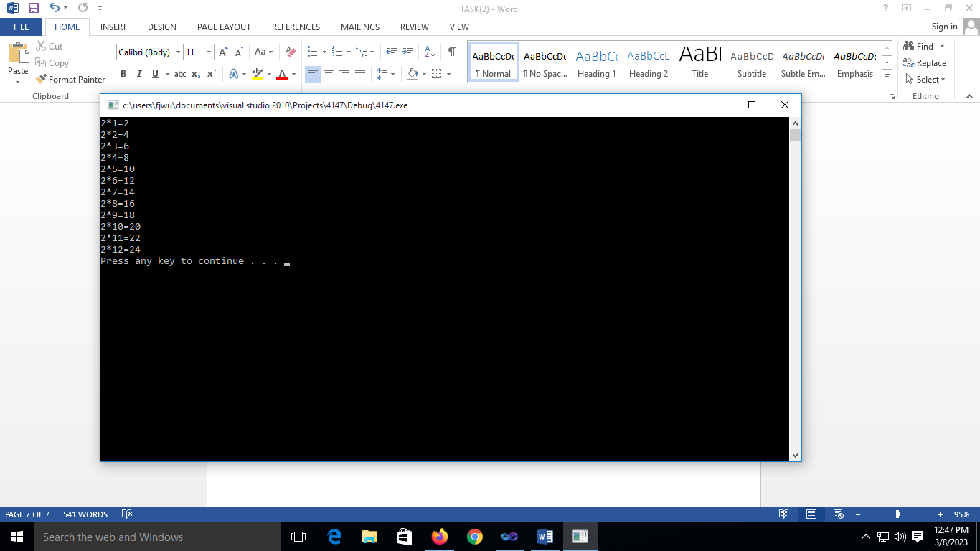

LAB#12

**TASK#01**

// gjuyik.cpp : Defines the entry point for the console application.

//

#include "stdafx.h"

#include< iostream >

using namespace std;

struct product { int price; float weight;

} apple,lemon;

int _tmain(int argc, _TCHAR* argv[])

{ apple.price=80;

apple.weight=1.8;

cout<<"Enter lemon.price = ";

cin>>lemon.price;

cout<<"Enter lemon.weight =";

cin>>lemon.weight;

cout<<"Apple.price = " <<apple.price<<endl;

cout<<"Apple.weight = " <<apple.weight<<endl;

cout<<"Lemon.price = "<< lemon.price<<endl;

cout<<"Lemo.weight = "<< lemon.weight<<endl;

system("pause") ;

return 0;

}

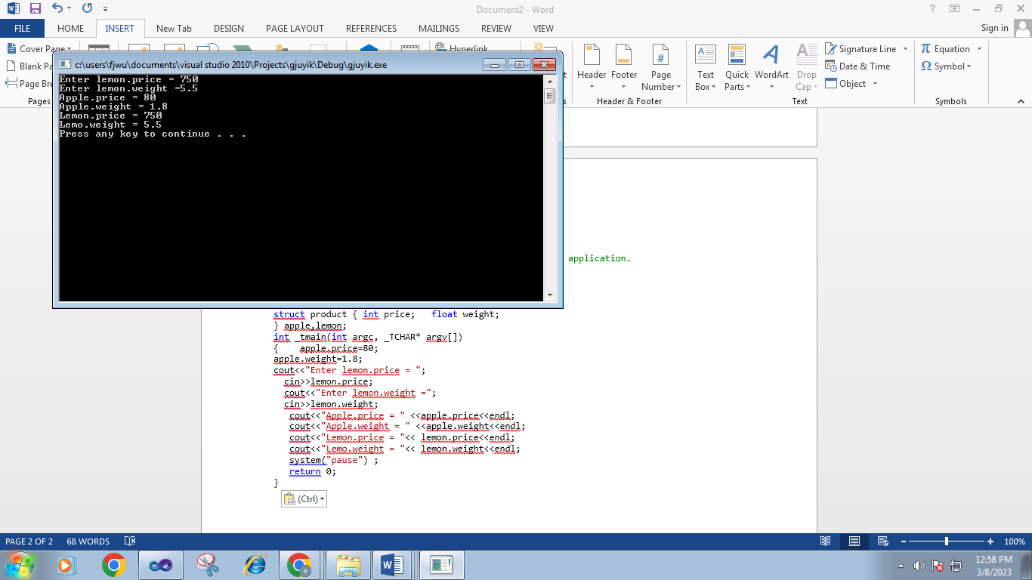

// dgfg.cpp : Defines the entry point for the console application.

//

#include "stdafx.h"

#include< iostream >

using namespace std;

struct mobile

{ char model[20];

int memory; float cam;

} sony={"xperia",16,12.3},samsung;

int _tmain(int argc, _TCHAR* argv[])

{ cout<<"samsung.model = ";

cin>>samsung.model;

cout<<"enter samsung.memory =";

cin>>samsung.memory;

cout<<"enter samsung.cam=";

cin>>samsung.cam;

cout<<" sony.model="<<sony.model<<"\n sony.memory ="<<sony.memory<<"\n sony.cam= "<<sony.cam ;

cout<<"\n samsung.model=" <<samsung.model<<"\n samsung.memory=" <<samsung.memory<<"\n samsung.cam="<< samsung.cam;

system("pause") ;

return 0;

}

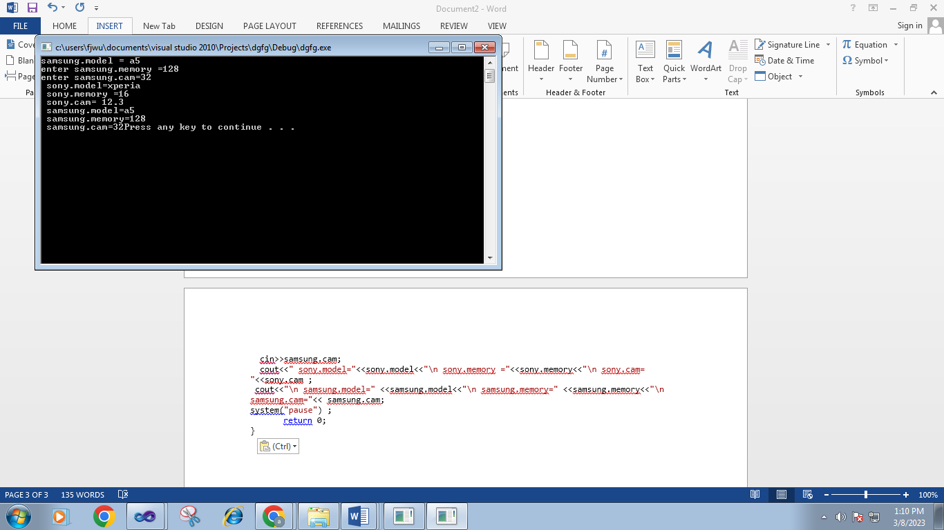

// dgfg.cpp : Defines the entry point for the console application.

//

#include "stdafx.h"

#include < iostream >

using namespace std;

struct Movies

{ char title[50]; int year;

} mine={"inception",2010}; void printmovie (Movies movie);

int _tmain(int argc, _TCHAR* argv[])

{ Movies yours;

cout << "Enter title: ";

cin >> yours.title;

cout << "Enter year: ";

cin >> yours.year;

cout << "My favorite movie is:\n ";

printmovie (mine);

cout << "And yours is:\n "; printmovie (yours);

system("pause") ;

return 0;

}

void printmovie (Movies movie)

{

cout << movie.title <<endl; cout << movie.year << endl;

}

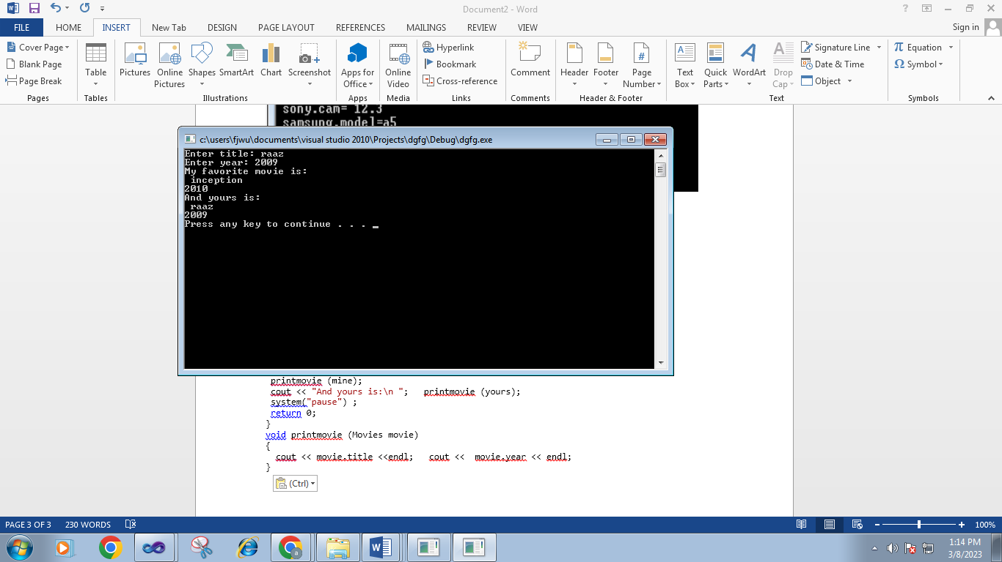

**TASK#02**

// dgfg.cpp : Defines the entry point for the console application.

//

#include "stdafx.h"

#include<iostream>

#include<string>

using namespace std;

struct student

{

string name;

int age;

string address;

int reg_no;

string university;

float CGPA;

}S1,S2,S3,S4,S5;

int _tmain(int argc, _TCHAR* argv[])

{

S1.age,S2.age,S3.age,S4.age,S5.age;

cout<<"enter th age of students"<<endl;

cin>>S1.age>>S2.age>>S3.age>>S4.age>>S5.age;

S1.name,S2.name,S3.name,S4.name,S5.name;

cout<<"enter the name of student"<<endl;

cin>>S1.name>>S2.name>>S3.name>>S4.name>>S5.name;

S1.address,S2.address,S3.address,S4.address,S5.address;

cout<<"enter the address of student"<<endl;

cin>>S1.address>>S2.address>>S3.address>>S4.address>>S5.address;

S1.reg_no,S2.reg_no,S3.reg_no,S4.reg_no,S5.reg_no;

cout<<"enter the reg_no of student"<<endl;

cin>>S1.reg_no>>S2.reg_no>>S3.reg_no>>S4.reg_no>>S5.reg_no;

S1.university,S2.university,S3.university,S4.university,S5.university;

cout<<"enter the university of student"<<endl;

cin>>S1.university>>S2.university>>S3.university>>S4.university>>S5.university;

S1.CGPA,S2.CGPA,S3.CGPA,S4.CGPA,S5.CGPA;

cout<<"enter the CGPA of student"<<endl;

cin>>S1.CGPA>>S2.CGPA>>S3.CGPA>>S4.CGPA>>S5.CGPA;

cout<<"AGE OF STUDENT"<<S1.age<<S2.age<<S3.age<<S4.age<<S5.age;

cout<<"namme of students"<<S1.name<<S2.name<<S3.name<<S4.name<<S5.name;

cout<<"addres of student"<< S1.address<<S2.address<<S3.address<<S4.address<<S5.address;

cout<<"CGPA OF STUDENT"<<S1.CGPA<<S2.CGPA<<S3.CGPA<<S4.CGPA<<S5.CGPA;

cout<<"REG_ NO OF STUDENT"<<S1.reg_no<<S2.reg_no<<S3.reg_no<<S4.reg_no<<S5.reg_no;

cout<<"university name of student"<<S1.university<<S2.university<<S3.university<<S4.university<<S5.university;

system("pause");

return 0;

}

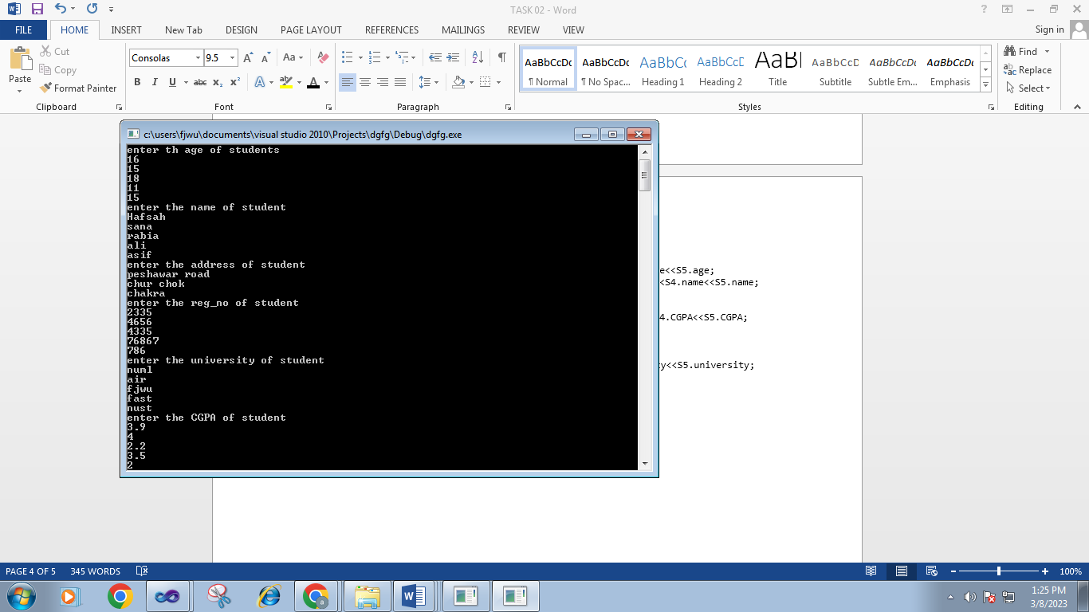

**TASK#03**

#include <iostream> #include <string> using namespace std;

struct result

{

string name; int reg_no; int marks[4]; int total_marks;

};

int main()

{

result student1 = {"Sawaira", 12345, {85, 90, 92, 88}, 0}; result student2 = {"sana", 67890, {80, 87, 91, 89}, 0}; for (int i = 0; i < 4; i++) {

student1.total_marks += student1.marks[i];

}

for (int i = 0; i < 4; i++)

{

student2.total_marks += student2.marks[i];

cout << "Student 1:" << endl; cout << "Name: " << student1.name << endl; cout << "Reg No: " << student1.reg_no << endl; cout << "Total Marks: " << student1.total_marks << endl;

cout << "Student 2:" << endl; cout << "Name: " << student2.name << endl; cout << "Reg No: " << student2.reg_no << endl; cout << "Total Marks: " << student2.total_marks << endl;

return 0;

}

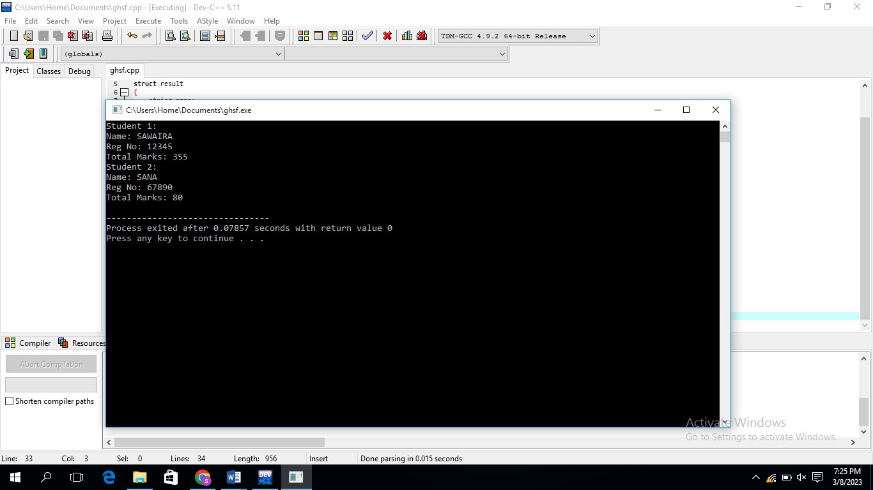

**TASK#04**

#include <iostream> using namespace std;

struct flight

{

int Flight_no;

int Hours; int Minutes; int Seconds;

};

void Display_time(const flight& f)

{

cout << "Arrival time for flight " << f.Flight_no << ": "; cout << f.Hours << " hours, " << f.Minutes << " minutes, " << f.Seconds << " seconds" << endl;

}

int main()

{ flight f1,

f2;

cout << "Enter arrival time for flight 1 (hours minutes seconds): "; cin >> f1.Hours >> f1.Minutes >> f1.Seconds; f1.Flight_no = 1;

cout << "Enter arrival time for flight 2 (hours minutes seconds): "; cin >> f2.Hours >> f2.Minutes >> f2.Seconds; f2.Flight_no = 2;

Display_time(f1); Display_time(f2);

return 0;

}

